**[www.aloa.org](http://www.aloa.org)**

e Official Publication of ALOA—An International Association of Security Professionals

**Introducing the**

**iButton!**

PLUS!

Safe Deposit Locks

LUhy I sn’t My Business Making Money? RLOfl Staff Ueteran Retires and MORE!

SC|_| 3.0IGIJ 303

Stephen L. Gebbia CML PO Box 48088 Atlanta GA 30362-1088

liillilliimlliilliiiililiiilllliiiliililiililiililiiliiillil

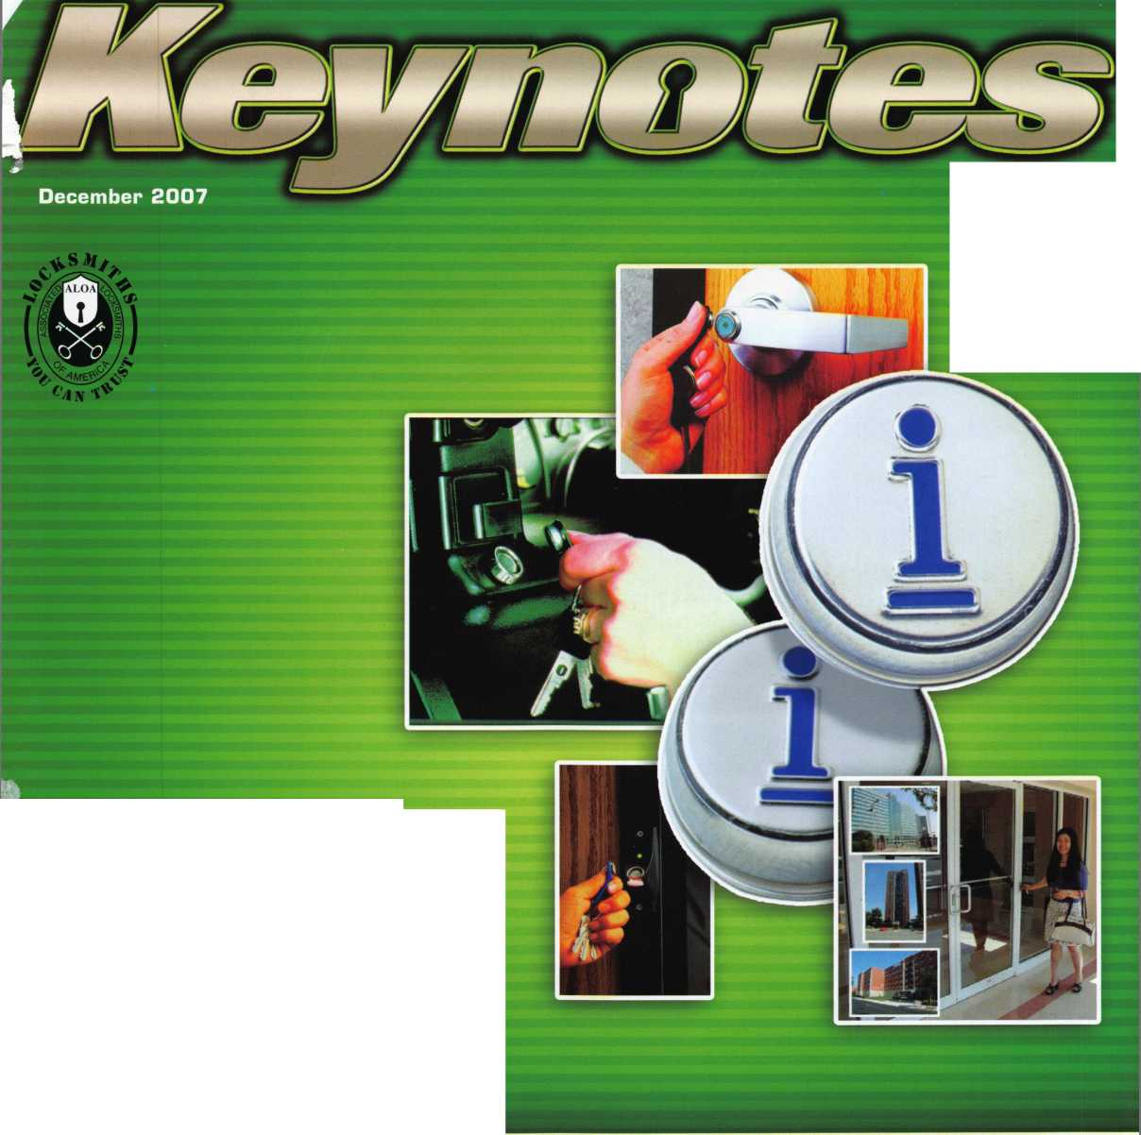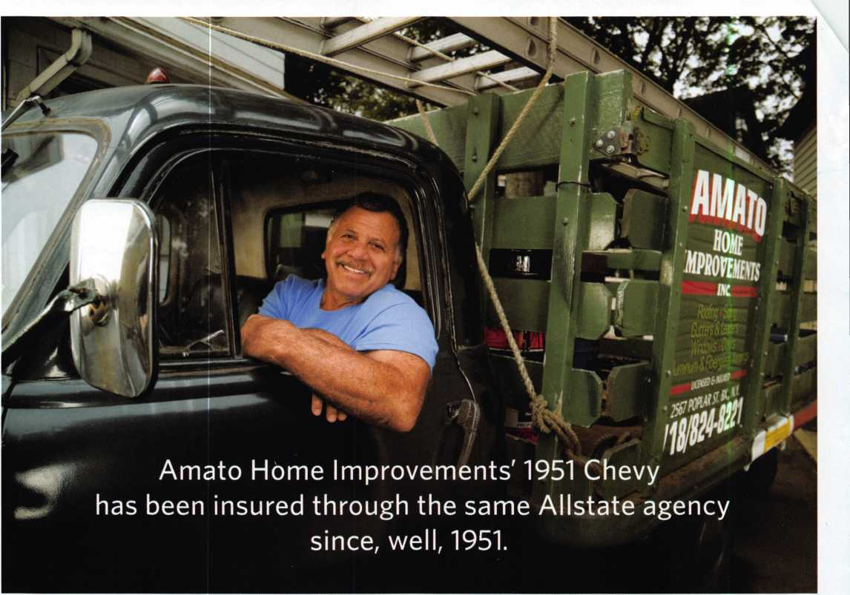

y

rears ago, Joe Amato's father  
bought a commercial vehicle

policy from Allstate Agent  
Ralph Borsella. Today, Ralph  
Borsella, Jr., services the policy,  
and Joe runs the family business.  
Through many years and two  
generations, their business  
relationship is still going strong.  
Just like Joe's '51 Chevy.

**ALLSTATE AGENTS VALUE LONG-TERM  
CUSTOMERS AS MUCH AS YOU DO.**

Our agents understand the unique needs of business  
owners like you. Because they're business owners, too.  
They'll help you get the insurance that's right for your  
business at a competitive price. And if you need to file a  
claim, they'll help you get back on the road fast. When  
your livelihood relies on your vehicle, you need coverage  
you can rely on. That's Allstate's Stands

Call now to save on Allstate Commercial Vehicle Insurance.

FOR AN ALLSTATE AGENT NEAR YOU, CALL 1-888-322-3078

**# Allstate**

You're in good hands.

***Auto Home Life Retirement***

Subject to availability and qualifications. Life insurance and annuities issued by Allstate Life Insurance Company, Northbrook, IL and Lincoln Benefit Life Company, Lincoln, NE. In New York, Allstate Life Insurance Company of New York, Hauppauge, NY. Property-casualty insurance products issued by Allstate Fire and Casualty Insurance Company, Allstate Indemnity Company, Allstate Insurance Company, Allstate Property and Casualty Insurance Company, Allstate County Mutual Insurance Company, Irving, TX and Allstate New Jersey Insurance Company, Bridgewater, NJ. © 2007 Allstate Insurance Company

**H.L. Flake COa**

Over 95 years of quality service

>>

***MATRIX*** 0

**bb—wng**

Please know that if you have a preference on your delivery carrier, it may extend the delivery time of your package. The delivery time will not exceed 3 business days.

FREE FREIGHT is just  
a small order away!

You are never more than 3 days away!

FREE GROUND FREIGHT WITH:

**I 1** $ 95.00 order

**)** $115.80 order

MU $135.°° order

FREE FREIGHT

(excludes key machines, safes, & bulk key orders)  
(within contiguous 48 states)

BUSINESS DAYS

**3 DAYS AWAY**

2 DAYS AWAY

1 DAY AWAY

OVER WEEKENDS, ADD 2 DAYS



***[www.hlflake.com](http://www.hlflake.com)***

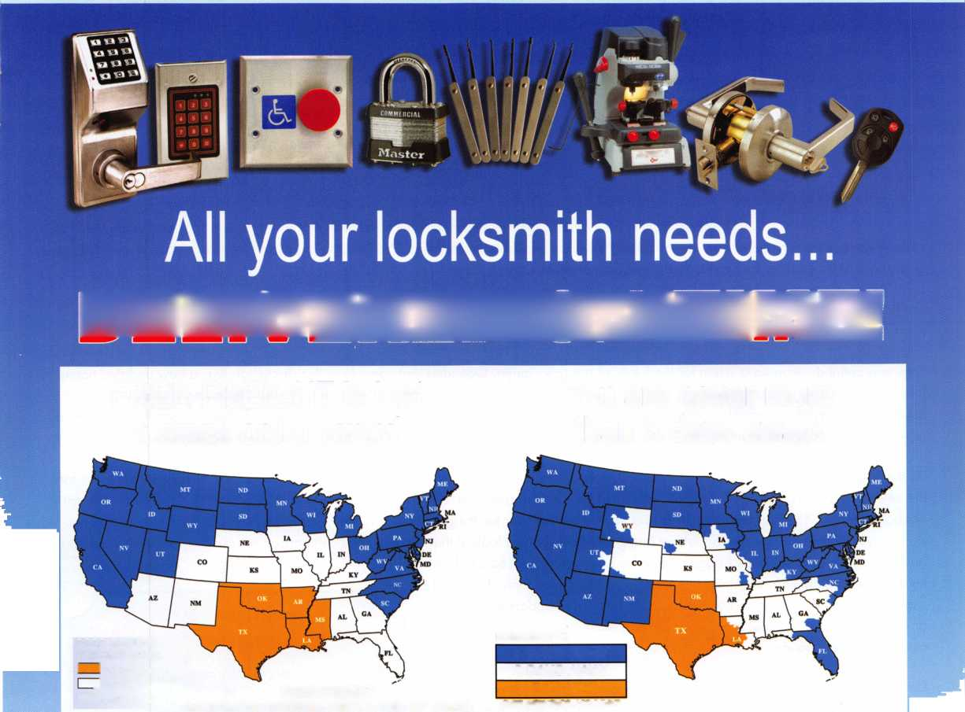

|  |  |  |
| --- | --- | --- |
| p r e s i d | (D | Mai |
| view | p o i | n t |

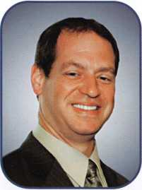

Dear Members:

I hope everyone was able to read the summary of the Board of Directors meeting that was published in the  
November issue of Keynotes. As 2008 approaches, the Board is ready and excited to implement many  
new ideas.

Keynotes is now available to our members on the website. It has been updated with new features like a  
member spotlight article, an exhibitor spotlight, and will soon feature a marketplace section for quick refer-  
ence to products and services. A business article will also be included in each issue.

The PRP will soon be available on line. Arrangements have been made with testing facilities nationwide to make it easier for everyone to take the tests. Results will be available immediately. We are also in the development stages of new PRP tests and designations for locksmiths that only do automotive work.

The association has purchased new management software which will allow us to be more efficient. A new website is also in develop­ment in conjunction with this program.

Time was spent developing a vision for the future of our association. One idea that came from this discussion was a new updated name for our organization. Our members do more than just locksmithing; we are security professionals. We will be having a contest this year for members to send in suggestions for our new name. Another idea is a membership drive. We will offer $25 to anyone that sponsors a new person for active membership for 2008. Look for more details about these and other programs in upcoming Keynotes.

As the Board took time to plan for the future of our organization, it is time for you to plan for the upcoming year. Whether your focus for  
the new year is personal or professional, now is the time to start planning. Look back at 2007. Was it profitable? Do you make enough  
or charge enough to cover your expenses and have some left over for the good things in life? Every year, some of the trade magazines  
do a survey of the average prices that are being charged. Do you look at that, do you do a comparison to your own pricing? When a  
business owner sees that the average charge for labor might be $65 per hour, and

he is only charging $35, they might be leaving money on the table that could be  
used to better him or herself. That money could be used to update equipment  
or to even attend some education. After all, one of the main focuses of an  
association is education.

During the writing of this message I have just learned that Mary May is retiring  
at the end of this month. Mary has been with ALOA for 27 years. Bob Mock  
awarded Mary with the President's Award last year to show our appreciation  
of all her hard work. She will be sorely missed.

Have a safe and prosperous new year,

HAPPY NEW YEAR

H appiness depends upon your outlook on life. A ttitude is just as important as ability.

P assion find yours this year!

P ositive thoughts make everything easier.

* ou are unique, with special gifts, use them.

N ew beginnings with a new year.

E nthusiasm a true secret of success.

W ishes may they turn into goals.

* ears go by to quickly, enjoy them.

E nergy may you have lots of it.

A ppreciation of life, don't take it for granted.

R elax take the time to relax in this coming year.

Ken Kupferman, CML, CPS

Keynotes • December 2007

Just call 310-575-5027 and receive:

1. ALOA Index of Documents (1 pg)
2. Reasons to Join ALOA (2 pg)
3. Locksmith Career Summary (3 pgs)
4. Locksmith School List (1 pg)
5. ACE Class Schedule (1 pg)
6. Certification Information (5 pgs)
7. PRP Category List (1 pg)
8. ALOA Membership Application (1 pg)
9. ALOA List of Benefits (1 pg)
10. ASF Scholarship Application (1 pg)
11. ASF Scholarship Information (1 pg)
12. ALOA Video Library Order Form (1 pg)
13. Safe & Vault Technicians Association Membership Ap­

plication/Subscription Form (2 pgs)

1. Recertification Information (4 pgs)
2. Legislation Action Network Newsletter (2 pgs)
3. Various State Law Issues (8 pgs)
4. Industry Position Paper (1 pg)
5. ALOA Convention Class Schedule (3 pgs)
6. ALOA Convention Class Descriptions (30 pgs)
7. ALOA Convention Registration Forms (4 pgs)
8. Board of Directors Nomination Form (2 pgs)
9. ALOA Company Membership Application (2 pgs)

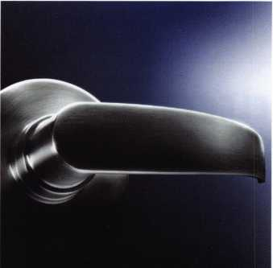

**BEAUTIFUL**

**ON THE OUTSIDE.  
INTELLIGENT  
ON THE INSIDE.**

Finally, electronic access  
control that looks as good  
as it works. Introducing the  
5V-1 Door Lock System from  
SimonsVoss - the world’s  
first electronic access control  
system contained entirely  
inside the handle.

Backed by more than a decade  
of German engineering,  
this completely wireless,  
network-ready system can  
be used over 150,000 times  
without changing batteries.  
It’s time to experience  
the beauty of a keyless world.

[www.simons-voss.us](http://www.simons-voss.us)

414.421.2481

**Simons=Voss**

technologies

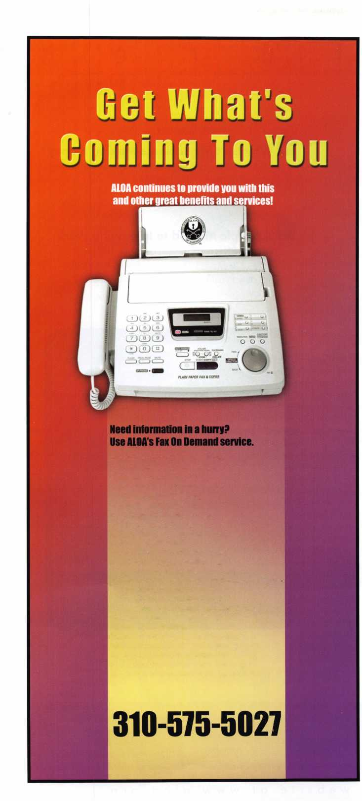

features

ELECTRONIC LOCKS

10

Cool Tool Makes a Splash

iButton - Access Control Key with world-class digital security and stainless-steel durability.

**33**

Why Isn't My Business Making Money?

Find out what steps you can take to make the money start rolling in.

by Sam Horn

**14**

Exhibitor Spotlight:

Pacific Lock Company

See what this family manufacturing company is all about.

**18**

Member Spotlight:

John Arnold - Key Express

22

Membership Mix

Time to Renew? What's my ROI?

by Ellen McEwen, Membership Developement Manager

**24**

Beloved Staff Member Retires

With as many conventions under her hat as hair-style changes, Mary May has broken many hearts by an­nouncing her retirement from ALOA.

**28**

Board Nominations

**30**

Starting Safe Deposit Work

Greg Perry shows you how with the right knowledge and tools safe deposit work can be less frustrating and difficult.

by Greg Perry, CML, CPS

**42**

A Simple Method to Improving Work place Efficiency

70% of employers are visual learners. How will this affect your company's ability to compete in todays marketplace?

|  |  |  |
| --- | --- | --- |
| r |  |  |
| AD INDEX |  |  |
| Allsfate | Inside Front Cover |  |
| H.L. Flake | 1 |  |
| Fax On Demand | 3 |  |
| Simon Voss | 3 |  |
| North Bennett Street School... | 7 |  |
| Pacific Lock | 15 |  |
| North American Bancard | 21 |  |
| Chase Paymentech Solutions. | 23 |  |
| SAFETECH 2008 | 27 |  |
| A&B | 40 |  |
| Turn 10 | 40 |  |
| ClearStar | 40 |  |
| PBP | 40 |  |
| Door King | 41 |  |
| CCL | 43 |  |
| Jet Hardware | Inside Back Cover |  |
| ALOA 2008 | Back Cover |  |
| L. |  |  |

**Departments**

|  |  |  |  |  |  |  |  |  |  |
| --- | --- | --- | --- | --- | --- | --- | --- | --- | --- |
| Presidential |  | Executive | 5 | Calendar | 8 | Classified | 35 | Legislative ... | 38 |
| Viewpoint | 2 | Applicants .... | 6 | Core | 9 | Associate Members | 36 | Crossword... | 44 |

Visit our NEW website at [www.aloa.org](http://www.aloa.org)

executive

Volume 53, Issue 11

Additional contact information for the ALOA Board is available on the ALOA website— [www.aloa.org](http://www.aloa.org) or by contacting the ALOA office at 3500 Easy Street; Dallas, TX 75247; (800)532-2562; FAX (214)819-9736; e-mail [aloa@aloa.org](mailto:aloa@aloa.org).

*'4* V*’



Editor & Director of Creative Services

Betty Southerland [betty@aloa.org](mailto:betty@aloa.org)

Advertising Sales

Kim Hammond voice: 817-645-6778

Fax: 817-645-7599 e-mail: [adsales@aloa.org](mailto:adsales@aloa.org)

Executive Director

Charles W. Gibson, Jr., CAE [charlie@aloa.org](mailto:charlie@aloa.org)

Associate Executive Director

David Lowell, CML, CMST [david@aloa.org](mailto:david@aloa.org)

Convention & Meetings Manager

Jo Anne Mims [joanne@aloa.org](mailto:joanne@aloa.org)

Operations/Membership Manager

Mary May [mary@aloa.org](mailto:mary@aloa.org)

Director of IT Operations

Greg K. Jackson [greg@aloa.org](mailto:greg@aloa.org)

Comptroller

Kathy Romo [kathy@aloa.org](mailto:kathy@aloa.org)

Membership Development Manager

Ellen R. McEwen [ellen@aloa.org](mailto:ellen@aloa.org)

Convention & Meetings Assistant Karen Lyons  
Mail Room Coordinator Kevin Wesley

Graphic Designer Margarita Garza

Accounting Coordinator Joyce Nixon

Assistant Education Manager Bob Stafford, CML  
Legislative Manager Tim McMullen, JD, CAE

Contributors

Jerome Andrews, CML Paul Chandler, CRL Claire Cohen, CML Brian Costley, CML, CMST Eric Costley, CRL

Ray D'Adamo, CML  
Billy Edwards, CML  
Dan Graffeo, CRL,CMST  
Jim Hancock, CPL  
Jeff Nunberg, CML, CMST

Randy Simpson, CML, CPP Robert Stafford, CML Dave Thielen, CML Greg Perry, CML,CPS

Tom Seroogy

Charles Stephenson, CPS

Dennis Watanabe, CML, CMST

Mission Statement: The Associated Locksmiths of America, Inc. is dedicated to enhancing the professionalism, education and ethics among  
locksmiths and those in related sectors of the physical security industry. With approximately 8,000 members in the United States, Canada and the free-  
world, ALOA is poised to help members obtain the knowledge, the strength, and the confidence to perform their role in the physical security field with  
pride and dignity. But it is only through active involvement and participation that ALOA can fully achieve its potential—and can help members to achieve  
theirs.

Policies: Keynotes® is the official publication of the Associated Locksmiths of America, Inc. (ALOA). Keynotes® acts as a moderator without approving,  
disapproving, or guaranteeing the validity or accuracy of any data, claim, or opinion appearing under a byline or obtained or quoted from an ac-  
knowledged source. The opinions expressed by the authors do not necessarily reflect the official views of ALOA. Also, appearance of advertisements and  
new products or service information does not constitute an endorsement of products or services featured by the Association. The Association does not ac-  
cept responsibility for the inaccuracy of any data, claim, or opinion appearing in this publication, due to typographical errors on the part of the authors,  
Association staff or its agents.

Editor's Note: This publication is designed to provide accurate and authoritative information in regard to the subject matter covered. It is provided and  
disseminated with the understanding that the publisher is not engaged in rendering legal or other professional services. If legal advice and other expert  
assistance is required, the services of a competent professional should be sought.

Authors7 Payment: Payment for eligible submissions to Keynotes will be based on the following criteria: topic, time spent and past contributions. Authors who  
regularly submit to Keynotes® are generally paid a higher rate. The latter is especially true of authors who write to fit specific editorial needs and submit said copy  
by Keynotes® deadlines. As a general guideline: Average payment for a 750 word, business or light' technical article would be $200. Payment for a 1500 word  
article involving significantly higher time and research efforts would be $400.

Payment will not be offered for articles submitted by ALOA employees or members of the ALOA Board of Directors (unless material is of a technical na-  
ture), nor for articles submitted by a company that promote that company's products or services. ALOA reserves the right not to pay for articles submitted  
by an individual(s) that promote a particular company's products or services.

Disclaimer: The Associated Locksmiths of America, Inc., (ALOA), reserves the right to refuse any article for any reason. Additionally, ALOA reserves  
the right to edit, amend or modify any article submitted for publication in order to preserve technical accuracy, clarity, fairness or grammatical correct-  
ness. ALOA will make the best efforts to notify the author of any changes. The extent of ALOA's liability for any article or information contained therein  
will be a notice of correction or retraction in the next possible issue.

Keynotes® (ISSN 0277 0792) is published monthly except for the combined June/July issue by The Associated Locksmiths of America, Inc.,  
3500 Easy St., Dallas, TX 75247-6416. Telephone: (214) 819-9733; FAX (214) 819-9736; e-mail [aloa@aloa.org](mailto:aloa@aloa.org). Subscription rates for  
members —$15.00 per year. Periodical class postage paid at Dallas, Texas. POSTMASTER: Send address changes to: Keynotes, 3500 Easy St., Dallas,  
TX 75247-6416. © Copyright 2003, All rights reserved. No part of the contents may be reproduced or reprinted in any form without prior  
written permission of the publisher.

President

Ken Kupferman, CML, CPS  
(813) 232-7600  
[president@aloa.org](mailto:president@aloa.org)

Secretary

John Soderland, CML, CMST  
(414) 327-5625  
secreta ry@a loa. org

Directors, Northeast

Tom Foxwell  
(410) 206-5772  
ned i rector@a loa. org

Robert D. DeWeese, CML, CPS  
(410)285-0101  
ned i rector@a loa. org

Directors, Southeast

Tom Gillingham, Jr., CML, CPS  
(615) 300-3777  
sed i rector@aloa. org

Steve Myslik, CRL  
(843) 321-9200  
sedirector@aloa .org

Director, North Central

William Smith, RL  
(920) 893-5282

Guy Spinello, RL  
(815) 394-1000

[ncdirector@aloa.org](mailto:ncdirector@aloa.org)

Director, South Central

CD Lipscomb, CML, CPS  
(903) 874-3522  
[scdirector@aloa.org](mailto:scdirector@aloa.org)

Directors, Southwest

Greg Parks, CRL  
(858) 271-1155  
swd i rector@a loa. org

Gordon Racine, CML  
(719) 384-4707  
swd i rector@a loa. org

Director, Northwest

Keith E. Whiting, CML, CFL  
(360) 601-5656  
[nwdirector@aloa.org](mailto:nwdirector@aloa.org)

Director, International

Hans Mejlshede, CML  
(453) 539-3939  
eurd i rector@aloa. org

Director, Associate

Dan Floeck  
(800)231-4105  
asd i rector@aioa. org

Trustees

[trustees@aloa.org](mailto:trustees@aloa.org)

Robert E. Mock  
(856) 863-0710

Randy Simpson, CML, CPP  
(281) 240-5959

William Young, CML, CPS  
(610) 647-5042

Past Presidents

2005-2007 Robert E. Mock  
2003-2005 William Young, CML, CPS  
2001-2003 Randy Simpson, CML  
1999-2001 John Greenan, CML, CPS  
1997-1999 Dallas C. Brooks  
1995-1997 David Lowell, CML, CMST  
1993-1995 Breck Camp, CML  
1991-1993 Henry Printz, CML  
1989-1991 Evelyn Wersonick, CML, CPS  
1987-1989 Leonard Passarello, CPL  
1985-1987 Joe Jackman, CML  
1983-1985 Stanley Haney, CPL  
1981-1983 Louis LaGreco, CPL  
1979-1981 John Kerr, RL  
1977-1979 Clifford Cox, CML  
1974-1977 Charles Hetherington  
1972-1974 Gene Laughridge  
1970-1972 William Dutcher, RL  
1968-1970 Constant Maffey, RL  
1966-1968 Harold Edelstein, RL  
1964-1966 William Meacham  
1962-1964 Robert Rackliffe, CPL  
1960-1962 Edwin Toepfer, RL  
1956-1960 Ernest Johannesen

Keynotes • December 2007



APO

Adrian W. Russell

Sponsor: Terry L. Loomis CRL

Bella Vista

Nathaniel Sweeney

Malvern

Robert E. Lafond

Bakersfield

Patrick Brandon

Dublin

William J. Brown

Modesto

Octavio Mendoza

Rio Vista

Jose D. Martinez

West Sacramento

Matthew Slayter

Fort Collins

Rod Rogers

Sponsor: Robert J. Reynolds CRL, CPS

Atlanta

Hezekiah Montia Yosef Ozeri

Loganville

Craig Bowie

Rincon

Edward W. Martin

Sponsor: Jack Walder

EH

Waynesville

Jason Kimpel

m

Lebanon

Michael Haas

Salem

Alan W. Conant

Columbia City

Troy A. Gawthrop

IHHHH

Morehead

Adrian Feria

Sponsor: Michael K. Yarberry CML, CPS

Baton Rouge

Tyrone E. Campbell

Leominster

Stephan Chromiak

Sponsor: Charles E. Batcke CPL, CPS

Westbrook

Kevin T. Gaudet

Sponsor: John H. Havens CRL

Spicer

Steve Hogenson

Sponsor: A Lowell Torkel- son CRL

Waterloo

Jeffrey Ford

Rahway

Leonard F. Grant III

Sponsor: Robert E. Mock

Angel Fire

Charles E. Hasford

Las Vegas

Ben Payne

Sponsor: Robert J. Reynolds CRL, CPS

Dave Penney

New York

Joseph Zigelstein

Sponsor: Robert E. Mock

Rfll

Bartlesville

John E. Bradley

Sponsor: Romie G. Holder Jr, CRL

Pawhuska

Nathan W. Butcher

Sponsor: Johnny A. Stew­art

Mt Pleasant

Dariush Pour- moghadam

Memphis

U Lynes

Sevierville

Samuel R. Richter

Kennewick

Mike E. Karch

Sponsor: James M. Watt CML, CPS

Suamico

Ronald Somer- halder RL

Sponsor: J Casey Camper CML, CPS

Worthing

Peter Deering

Japan

Saitama

Shoyo Kobori

Sponsor: Takashi Kuwana CRL

These applicants are scheduled for clearance as members of ALOA. The names are published for member review and comment within 30 days of this Keynotes issue date, respectively, to ensure applicants meet standards of ALOA's Code of Ethics. Protests, if any, should be addressed to the Membership Department and must be signed. Active Membership applicants (a) have worked in the industry two or more years. Allied Membership (AL) applicants are not locksmiths, but work in a security-related field. Apprentice Membership (AP) applicants have worked in the industry less than two years.

Keynotes • December 2007

Craft

your own career

in Locksmithing

Learn to be a locksmith at our conveniently  
scheduled hands-on morning program. Classes  
are given from 7:30 am - 12:30 pm. Over nine  
months you will learn to service, install and  
bypass a wide variety of locking devices including

residential, commercial and automotive locks. Master keying, electronic  
access, and safe manipulation round out a curriculum which is updated  
annually to incorporate the latest industry advancements. September and  
February admissions.

Other full-time courses offered are • Bookbinding • Cabinet & Furniture Making • Carpentry • Preservation Carpentry • Jewelry Making & Repair • Piano Technology • Violin Making & Repair

Financial aid is available for qualified students.  
Accredited member ACCSCT. Non-accredited  
workshops 1 week to 3 months also offered.

NORTH-BENNET-STREET-SCHOOL

AN EDUCATION IN CRAFTSMANSHIP 39 North Bennet St. • Boston, MA 02113 • (617) 227-0155

[www.nbss.org](http://www.nbss.org)

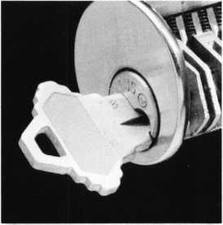

upcoming

events

1/16: Advancing Video Security with IP Technology Virtual Forum For more info visit [www.asisonline.org](http://www.asisonline.org)



2/2 Annual OMLA Distributor's Show Oklahoma City, OK Crowne Plaza Hotel Midwest Expressway Show hours are 9 AM to 4 PM Info on [www.omla.com](http://www.omla.com)

2/4-8 Physical Security: Introductory Applications & Technology Embassy Suites Lake Buena Vista Resort • Orlando, Fla. [www.asisonline.org](http://www.asisonline.org)

2/6-9 TLA Convention Austin, TX

Radisson Hotel Austin North 6000 Middle Fiskville Road Resv: (888) 201-1718

2/7-9 Certified Protection Professional (CPP) Review Hyatt Regency Boston - Financial District • Boston, Mass. [www.asisonline.org](http://www.asisonline.org)



2/9 North Carolina Locksmith's Assc. 2/1 2008 Regional Security Trade Show Renaissance Charlotte Suites Hotel 2800 Coliseum Drive Charlotte, NC 28217 Free Classes 2pm - 4pm • 8am - 1 pm • Cont: Laura J. Busse, CRL 919-828-9605

1-13 ASIS International Security 2/11-14: Conf: Risks & Opportunities in the Asia-Pacific Reg. Singapore For more info visit [www.asisonline.org](http://www.asisonline.org)

Crisis Management: Intro to the Response Plan & Adv. Topics Doubletree Houston Houston, TX For more info visit [www.asisonline.org](http://www.asisonline.org)

Security Metrics, Demonstrating the

Value of Security

Virtual Forum

For more info visit

[www.asisonline.org](http://www.asisonline.org)

2/13:

tc

<

Z

3/6-9 2008 Trade Show &

Security Conference IDN-Hardware Sales, Inc.

Novi, Michigan

Sheraton Detroit Novi, 21111

Haggerty Road

Cont: Ronald Weston

734-293-0082

or Bonnie Weston 734-293-006

3/10-13: Assets Protection Course 1

Grand Hyatt Denver Downtown Denver, CO For more info visit [www.asisonline.org](http://www.asisonline.org)

3/17-19: 26th Annual Government/

Industry Conference on Global Terrorism The Ritz-Carlton, Pentagon City Arlington, Va.

For more info visit [www.asisonline.org](http://www.asisonline.org)

3/31-4/5 SAFETECH 2008 SAVTA Convention & Tradeshow San Diego, Callifornia savta.org • 214-819-9771

**UPCOMING ACE CLASSES**

**December 3-8, 2007**

**December 6-8, 2007**

**January 11-12, 2008**

January 12, 2008 January 19, 2008 February 6-8, 2008

February 8-10, 2008

**February 21-23, 2008**

**March 10-15, 2008**

March 31 -April 5, 2008 April 19, 2008

April 25-26, 2008

Dallas, TX • ALOA Training Center • [www.aloa.org](http://www.aloa.org) Six-Day Basic Locksmithing Course

ALOA Education • 800-532-2562x101 • [education@aloa.org](mailto:education@aloa.org)

Dallas, TX • ALOA Training Center • [www.aloa.org](http://www.aloa.org)

Three-Day Master Keying Symposium

ALOA Education • 800-532-2562x101 • [education@aloa.org](mailto:education@aloa.org)

Dallas, TX • ALOA Training Center • [www.aloa.org](http://www.aloa.org)

Keyless Mechanical Lock Servicing w/L-20 PRP

Life Safety Codes w/L-07 PRP

ALOA Education • 800-532-2562x101 • [education@aloa.org](mailto:education@aloa.org) Casper, Wyoming • Wyoming Locksmiths Assn.

Automotive Locksmithing Update Jim O'Grady • 307-234-5932

Lincoln, Nebraska • Nebraska Chapt. of ALOA • [safeman@cox.net](mailto:safeman@cox.net)

Servicing Aluminum Storefront Doors

Elmer Howard • 402-676-8973

Austin, Texas • Texas Locksmiths Association Convention

Fundamental Locksmithing (3 days)

Basic Electricity & Electronics w/ L-l 3 PRP

Installing & Servicing Access Control w/L-40 PRP

John Arnold, CML • 972-245-9583 • [key.express@usa.net](mailto:key.express@usa.net)

Eagan, Minnesota • Minnesota Chapter of ALOA

Multipoint Hardware & Profile Cylinder Servicing

Professional Picking Techniques, Door Closers

Professional Impressioning Techniques, PRP Exam

Dana Lee, CML, CPS • 612-968-3257 • [dana337@mac.com](mailto:dana337@mac.com)

Dallas, TX • ALOA Training Center • [www.aloa.org](http://www.aloa.org)

Security Hardware Installers Course (3 days)

ALOA Education • 800-532-2562x101 • [education@aloa.org](mailto:education@aloa.org) Dallas, TX • ALOA Training Center • [www.aloa.org](http://www.aloa.org) Six-Day Basic Locksmithing Course

ALOA Education • 800-532-2562x101 • [education@aloa.org](mailto:education@aloa.org) San Diego, California • SAFETECH 2008 • [www.savta.org](http://www.savta.org) Safe & Vault Classes • SAVTA Education • 214-819-9771 Grand Island, Nebraska • Nebraska Chapt. of ALOA Installing & Servicing Access Contrl w/L-40 PRP Elmer Howard • 402-676-8973 • [safeman@cox.net](mailto:safeman@cox.net) Dallas, TX • ALOA Training Center • [www.aloa.org](http://www.aloa.org) CCTV for Locksmiths • ALOA Education 800-532-2562x101 • [education@aloa.org](mailto:education@aloa.org)

**UPCOMING PRP Sittings**

12/1/07 Saturday 8:00am • Hoover, AL • Benny Hopper

Alabama Locksmiths Assn. • [hoover6070@aol.com](mailto:hoover6070@aol.com) 205-823-2843 • JUST ADDED

12/8/07 Saturday 1:00pm • Dallas, TX • ALOA Certification

ALOA Training Center • [education@aloa.org](mailto:education@aloa.org) 800-532-2562x101

12/9/07 Sunday 1:00pm • Muskego, Wl • John Soderland, CML, CMST

[prolock@aol.com](mailto:prolock@aol.com) • 414-327-5625

1/12/08 Saturday 8:00am • Dallas, TX • ALOA Certification

ALOA Training Center • [education@aloa.org](mailto:education@aloa.org) 800-532-2562x101 • JUST ADDED

2/9/08 Saturday 8:00am • Austin, TX • ALOA Certification

Texas Locksmiths Association • [education@aloa.org](mailto:education@aloa.org) 800-532-2562x101 • JUST ADDED

2/10/08 Sunday 8:00am • Eagan, MN • Dana Lee, CML, CPS

Minnesota Chapter of ALOA • [dana337@mac.com](mailto:dana337@mac.com) 612-968-3257 • JUST ADDED

2/23/08 Saturday 8:00am • Dallas, TX • ALOA Certification

ALOA Training Center • [education@aloa.org](mailto:education@aloa.org) 800-532-2562x101 • JUST ADDED

3/15/08 Saturday 8:00am • Dallas, TX • ALOA Certification

ALOA Training Center • [education@aloa.org](mailto:education@aloa.org) 800-532-2562x101 • JUST ADDED

4/5/08 Saturday 8:00am • San Diego, CA • ALOA Certification

SAVTA - SAFETECH 2008 • [education@aloa.org](mailto:education@aloa.org) 800-532-2562x101 • JUST ADDED

4/26/08 Saturday 8:00am • Dallas, TX • ALOA Certification

ALOA Training Center • [education@aloa.org](mailto:education@aloa.org) 800-532-2562x101 •JUST ADDED

**Contact the ALOA Education De­partment for a list of classes and training offered in-house.**

? core

Condolences

Condolences are extended to the family and friends of Donald R. Bowman who passed in November. Donald was an ALOA Member since 1975.

Good Morning America

The Good Morning America report on Phony Locksmiths has been postponed. The producer of the piece, Allen Levin stated that every day the show producers have to de­cide what mix they think makes the best overall program. It's not uncommon for some­thing to be scheduled and then postponed. Check aloa.org for updates on scheduling.

Corporate Safe Specialists Announces Additions to R&D Team

Corporate Safe Specialists (CSS) announces two additions to its Research and Devel­opment organization. The Company has hired Randy Biela, a software engineer, and David Murch, a mechanical engineer.

Ed McGunn, President and CEO of the Company, stated "we now have an R&D de­partment of five full-time employees led by myself. I believe this to be the largest R&D team in the industry and rivals the R&D investment of most Self-Service companies.

Next year will be an exciting one from a product development perspective for CSS and its' customers." The Company is experiencing record demand for its1 networked products this year.

Mr. Murch joins CSS with more than 6 years' experience in mechanical engineering. Most recently, Mr. Murch was employed by Baldor Electric Company, where he served as Field Sales Engineer. Prior to joining Baldor in 2004, Mr. Murch spent 3 years with Swagelok in key engineering roles. Mr. Murch earned his BS in mechanical Engineer­ing from Ohio State University. Mr. Murch will be responsible for mechanical design and engineering of networked safe products.

Mr. Biela joins CSS with more than 3 years' experience in software engineering. Most recently, Mr. Biela was employed by Argonne National Laboratories, where he served as a government researcher and programmer. Prior to joining Argonne in 2006, Mr. Biela spent 2 years with Panduit Corporation in key production and networking roles. Mr. Biela earned his BS in Computer Sciences from Lewis University and is continuing his studies to earn a Master's degree in Information Security. Mr. Biela will be respon­sible for software design and development, and the continual improvement of user in­terfaces.

Founded in 1988, CSS is an industry leader providing innovative security solutions to retailers and restaurants globally. CSS safes, smart safes and kiosks feature electronic or biometric locks and can be configured to provide closed-loop cash management processes to minimize risk of theft. CSS is the only manufacturer of safes to offer 24/7/365 live technical phone support and has a U.S. service network that can pro­vide on-site service within four hours.

Kaba llco Software Updates and New Trade-In Program

Kaba llco is pleased to announce a Trade-In Program for owners of the SDD Program­ming Tools. This is an opportunity for owners to upgrade to the TKO.

For a limited time only, beginning January 2, 2008 owners can trade-in their SDD for a TKO at a very low trade-in price. The TKO will be new and fully loaded, including the 2007 updates.

Kaba llco realizes the importance of the SDD to its owner and has set up a special pro­cedure for expediting the exchange. Before ordering software updates for SDD units, owners are urged to check out this trade-in program. You'll save money and have an up-to-date programming tool. Kaba llco is notifying owners who have registered their SDD. For owners that may not have registered or that have not updated their contact information at Kaba llco, information is available from their llco Distributor or Kaba llco Customer Service at 1-800-334-1381.

Owners are encouraged to act quickly as this Trade-In offer expires March 2, 2008.

Software updates are listed at the Kaba llco Website. A Multiple Purchase Discount is available to owners that purchase two or more of these updates by February 29,

2008.

Edge Responder™ IP-reader access control system surpasses 200+ systems sold since April 2007 using HID Global's Networked Access Solutions technology

Middleware Associates announced recently that they have sold more than 200 licenses for their Edge Responder IP-reader access control solution since April of this year.

Edge Responder software works with the HID Global's EdgeReader/EdgePlus devices which were officially introduced in March, 2007.

"We have enjoyed phenomenal growth and adoption of our Edge Responder solution because of its simplicity to setup and configure the software and hardware using the HID Edge devices, as well as the tremendous cost advantages that the Edge technology provides to end users. In addition to our growing dealer/integrator base of resellers, a major retail franchisor has adopted our Edge Responder solution and is migrating from their legacy access control systems in over 400 of their existing retail locations to our Edge Responder solution while keeping their existing readers and cards. In addi­tion to installing more than one Edge Responder system per day to meet their migration needs, this customer's rapid growth is saving them tens of thousands of dollars over their older solution. With over 1200 retail franchise locations now sold and more than one new storefront added per day, Edge Responders' built-in import utility via Microsoft Excel is providing a simple migration from their legacy system," commented Gary Sheldt, General Manager of Middleware Associates.

"Now that the HID EdgeReader/EdgePlus devices are commercially available, we are enjoying the sea-change in customer acceptance of the "Edge"/IP-reader technology over traditional access control systems, much as the video surveillance marketplace has witnessed in the tremendous growth of IP video systems", noted Sheldt.

Edge Responder software is available in English, French, Portuguese and Spanish lan­guages currently. Interested parties can view a demo of Edge Responder online at [www.middleware-associates.com](http://www.middleware-associates.com)

Cool Tool Makes a Splash

iButton—Access Control Key with World-Class Digital Security and Stainless-Steel Durability

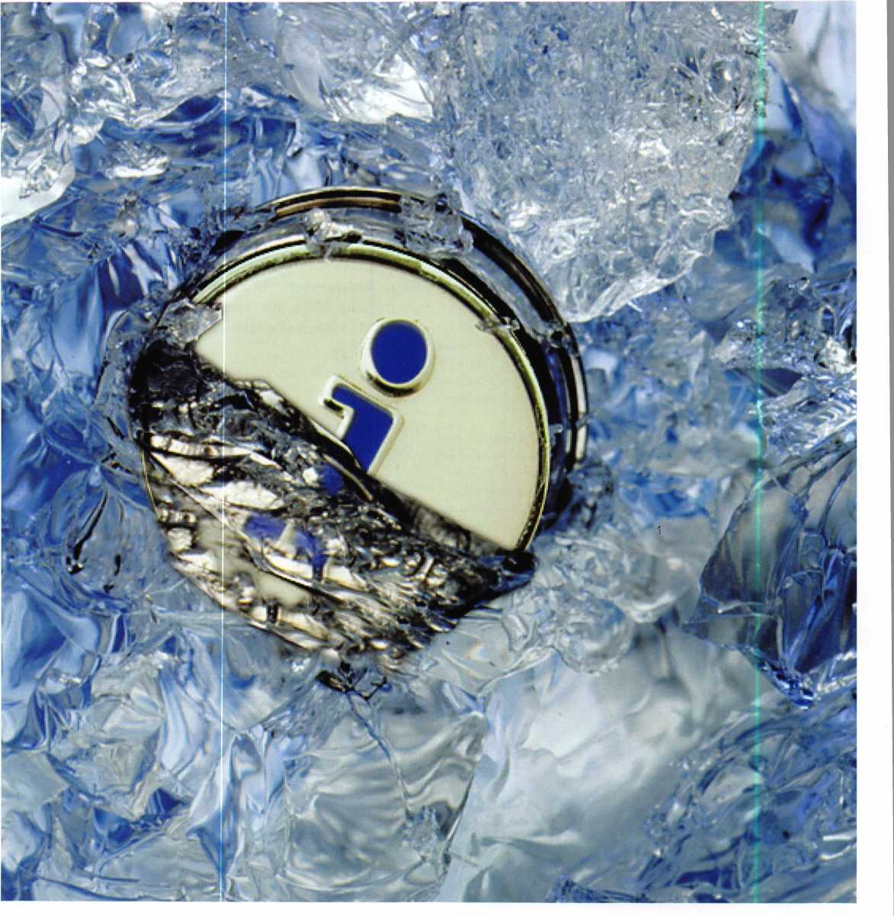

Computer Chip-Based Electronic  
Key Fits on a Keyring and Lasts  
10 Years

The iButton® is a computer chip enclosed in a 16mm

thick stainless steel can. Because of this unique and  
durable container, up-to-date information can  
travel with a person or object anywhere they go.

The steel iButton can be mounted virtually  
anywhere because it is rugged enough to with-  
stand harsh environments, indoors or outdoors.

It is small and portable enough to attach to a  
key fob, ring, watch, or other personal items, and  
be used daily for applications such as access control  
to buildings and computers, asset management, and  
various data logging tasks.

iButton Components

The Can and Grommet

An iButton uses its stainless steel 'can' as an electronic com­munications interface. Each can has a data contact, called the 'lid', and a ground contact, called the 'base'. Each of these contacts is connected to the silicon chip inside. The lid is the top of the can; the base forms the sides and the bottom of the can and includes a flange to simplify attaching the button to just about anything. The two contacts are separated by a polypropylene grommet.

The 1-Wire Interface

By simply touching the iButton to the two contacts described above, you can communicate with it through our 1-Wire® protocol. The 1-Wire interface has two communication speeds: standard mode at 16kbps, and overdrive mode at 142kbps.

The Address

Each iButton has a unique and unalterable address laser etched onto its chip inside the can. The address (e.g. 2700000095C33108) can be used as a key or identifier for each iButton.

iButton Versions

The iButton product line now comprises over 20 different products with different functionality added to the basic but­ton. iButtons come in the following varieties:

* Address Only
* Memory
* Real-Time Clock
* Secure
* Data Loggers

How Do I Get Information Into and  
Out of the iButton?

Information is transferred between the iButton  
and a PC with a momentary contact at up to  
142kbps. The user simply touches the iButton  
to a Blue Dot receptor or other iButton probe,  
which is connected to a PC. The Blue Dot re-  
ceptor is cabled to a 1-Wire adapter that is at-  
tached to a spare PC port. 1-Wire adapters exist for

USB, serial, and parallel ports. The Blue Dot receptor  
and 1-Wire Adapter are inexpensive.

The iButton is also the ultimate information carrier for Au- toID and many portable applications. Most handheld com­puters and PDAs can communicate with iButtons.

How Durable Is the iButton?

The silicon chip within the iButton is protected by the ulti­mate durable material: stainless steel. You can drop an iBut­ton, step on it, or scratch it. The iButton is wear-tested for 10-year durability.

What Can I Do with the iButton?

The iButton is ideal for any application where information needs to travel with a person or object. Affixed to a key fob, watch, or ring, an iButton can grant its owner access to a building, a PC, a piece of equipment, or a vehicle. Attached to a work tote, it can measure processes to improve efficiency, such as manufacturing, delivery, and maintenance. Some iButton versions can be used to store electronic cash for small transactions, such as transit systems, parking meters, and vending machines. The iButton can also be used as an elec­tronic asset tag to store information needed to keep track of valuable capital equipment.

What Do I Need to Put Together an iButton Application?

There are four components fundamental to any iButton appli­cation:

* iButtons
* A host system: this can be a PC, a laptop, a handheld computer, or an embedded system.
* A reader/writer device to get information into and out of



the button. This can be the Blue Dot mentioned above, a pen-style probe, or a handheld device.

• A layer of software to interface iButtons to computers and produce the desired information in the desired format. Several software development kits (SDKs) are download­able from the iButton website at no charge. iButton also offers 1-Wire Drivers for Microsoft platforms, along with the OneWireViewer, a demo application that can read/write/exercise any iButton.

How Much Does It Cost to Build a Simple iButton Application?

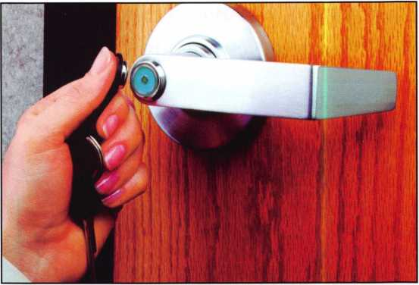

iButton technology can cost as little as $50 (US$), plus your programming time.

iButtons cost between $2 to $95 in quantities of one; larger quantities are discounted.

The Blue Dot receptor and 1-Wire Adpater, which together make a simple reader/writer device, cost between $38 and

$43.

The OneWireViewer demo software and SDKs are free from the iButton web site.

What Are the Advantages of iButtons Over Other Technologies?

When developing an iButton solution for an application, you can consider many complementary technologies. Bar codes, RFID tags, magnetic stripe, prox, and smart cards are some of the possibilities. Unlike bar codes and magnetic stripe cards, most of the iButtons can be read AND be written to. In addi­tion, the communication rate and product breadth of iBut­tons goes well beyond the simple memory products typically available with RFID. As for durability, the thin plastic of smart cards is no match for the strength of the stainless-steel- clad iButton.

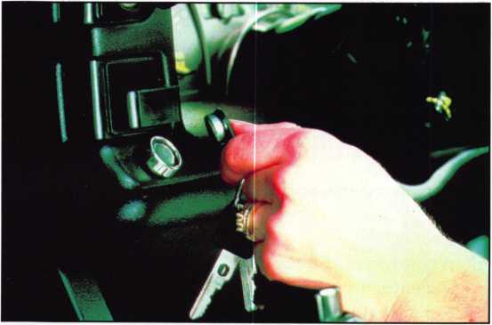

Applications

* Building Access
* Biometric Data Carriers
* Computer/Network Security
* eCash Systems
* Key Control Systems
* Standalone Locks
* POS Terminal Access
* Time and Attendance Systems

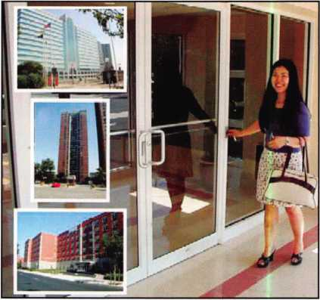

200,000 iButtons Open Doors in New York City

Access Controls International has installed their iButton ac­cess control systems, trade name "ComKey", in over 10,000 individual buildings with over 200,000 individual iButton credential holders in the New York City area.

Their newest project, the Newport community, is an upscale combined commercial / residential complex built by one of the world's largest private developers of rental properties, The Lefrak Organization.

Within Newport, all common area entrance doors, laundry room doors, mailroom doors and pedestrian gates are

equipped with ComKey access control for their 9,000 resi­dents. The doors are equipped with stainless steel, vandal proof ComKey (iButton) readers, which properly comple­ments the iButton's convenience and durability.

Some of the other prominent properties where ComKey ac­cess control has been used with overwhelming reliability and success are:

* Parkchester South Condominium - 30,000 users
* Windsor Park - 6,000 users
* The Trump Organization - 43 buildings - 10,000 users
* ACI
* The Lefrak Organization
* The Newport Community

Housing Authority-Senior Citizens Home

Locknetics Security Engineering has installed their "Locknet- ics On Board" system at the Laredo Housing Authority-Se­nior Citizens Home to increase security and enhanced resident convenience. The system includes Schlage Computer- Managed (CM) locks, Locknetics magnetic locks and touch- bars, and LockLink Express software.

Although the 40 year-old, 100-unit, seven-story senior citi­zens home had experienced no break-ins, both residents and staff were becoming more and more concerned that they weren't safe due to the number of transients in the area.

When the Housing Authority began looking for a solution, they wanted to heighten security, increase resident conven­ience, enhance flexibility, assure architectural integrity and meet the needs of the handicapped.

"We selected Schlage stand-alone, battery-operated CM locks with "Locknetics On Board" which allow our residents to use an iButton credential to obtain entry into the new exterior gate lock, the grounds, all common areas and their rooms," explains Rodrigo Garza, director of modernization and devel­opment for the Laredo Housing Authority. "This is very con­venient for the residents because they only need one credential to access all locks. Our residents simply touch the iButton fob to the iButton reader on the lock to gain entrance. Although several of our senior citizens were reluc­tant to use the new technology at first, once they got the hang of it, they fell in love with the system and the conven­ience it provides."

Down with  
Rekeying

Keeping track of  
keys and rekeying  
when necessary are  
real pains in the  
lock for many facil-  
ities. That’s espe-  
cially true for  
colleges, universities  
and schools. But  
one southern Cali-  
fornia college  
solved the challenge  
by installing Lock-  
netics computer-  
managed

stand-alone iButton  
locks at many of  
its doors.

The Santa Clarita Community College District, just north of Los Angeles, is one of the fastest growing community colleges in California and under almost constant construction to keep up with its increasing student population. Already, the Col­lege of the Canyons, situated on 153 acres, has more than 8,500 students.

According to Ray Briones, an eight-year veteran of the Col­lege’s maintenance department, “Three years ago, we were faced with a decision. We hadn’t been rekeyed for quite some time and, to make matters worse, we hadn’t been very good at keeping track of our keys. The College was experiencing rapid growth and wanted to increase its security levels.

“By using computer-managed [CM] iButton locks, we knew we could save money down the road in time and expense of rekeying every door on campus when someone walked off or lost their keys. We were right. Today, I simply reprogram a lock with my PDA by deleting the lost credentials and reissu­ing a new credential.”

About Maxim Integrated Products

Maxim Integrated Products was established in 1983. In 2001, Maxim acquired Dallas Semiconductor. Visit [www.maxim- ic.com/products/ibutton/news/brochure.cfm](http://www.maxim-ic.com/products/ibutton/news/brochure.cfm) for more infor­mation.

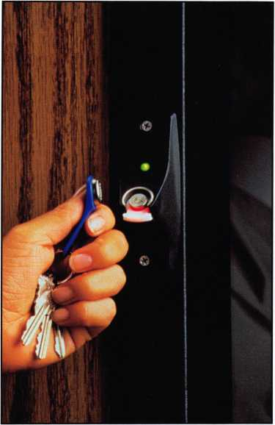

Welcome to our new monthly feature! Each month we will highlight a current ALOA Convention and Security Expo exhibitor with product information or important developments and innovation that you can use in your security-re­lated business. To be considered or to recommend an exhibitor, please send an email to Kim Hammond at [khammond@cdibb.com](mailto:khammond@cdibb.com).

**Pacific Lock Company  
21618 Manila Street  
Chatsworth, CA 91311  
888-562-5565  
[www.paclock.com](http://www.paclock.com)**

Pacific Lock Company ("PACLOCK" for short) is a family manufacturing company that builds highly customizable padlocks for the commercial and institutional locksmithing market. The core of the business is 5 & 6- pin tumbler padlocks in varying sizes from 1-1/2" to 2" rectangular shaped bodies as well as hockey-puck and round padlock bodies. Gen­erally speaking, if you can find it in Master Lock® or American Lock's® commercial catalog, then PACLOCK has a substitute product that matches.

What really sets PACLOCK apart from the competition is its aptitude to develop new products or services that make your business more efficient and effective. From its Shackle-PACs to its brand new PAC-SHIELDs, they have continually been on the forefront of innovation and creativity. Their "Your Logo, Your Locks" program leads the industry in custom laser en­graving. PACLOCK's new "XIC" hockey-puck padlocks are the only ones in the world that accept small-format interchangeable cores (SFICs) and key in knob (KiK) cylinders. Time and again PACLOCK is setting the standard.

Q PACIFIC LOCK

**UEj *“The Future of Padlocks ”***

**Plastic coatings are**

**for toys...**

**not padlocks.**

**(i 9^ PACLOCK's patented**

**Q An add-on steel (i.e., not plastic) shroud protec**

**B) tion for any rectangular body padlock.**

**n The "right" way to do weather-proof high secu-**

**@ rity ~ a brass PACLOCK with a steel PAC- SHIELD. No cracking here.**

**Q Cut shrouded locks from your inventory.**

**O Instead, keep a couple PAC-SHIELDs on hand and create your shrouded locks when you need them.**

**Q A hammer is all you need to bend the tab at the**

**S bottom securing the PAC-SHIELD.**

**Q Now available for the 1-3/4" padlock bodies;**

**B) sizes soon available: 1-1/2", 2", and the round 2-1/2" bodies.**

**Protected Under US Patent #5,146,771**

Patented Design

Add “Your Logo, Your Locks” for  
ultimate customization

Take a Brass (Weather Resistant)  
Padlock and Transform it into a High  
Security Weather Resistant Padlock

Hammer Down Tab to Secure Padlock into PAC-SHIELD

**PACIFIC LOCK**

**PACIFIC LOCK**

*A Family Owned & Operated Small Business*

**Call Your Local Distributor or PACLOCK directly at 888-562-5565 or 818-678-6500**

***UNLOCK THE POSSIBILITIES***

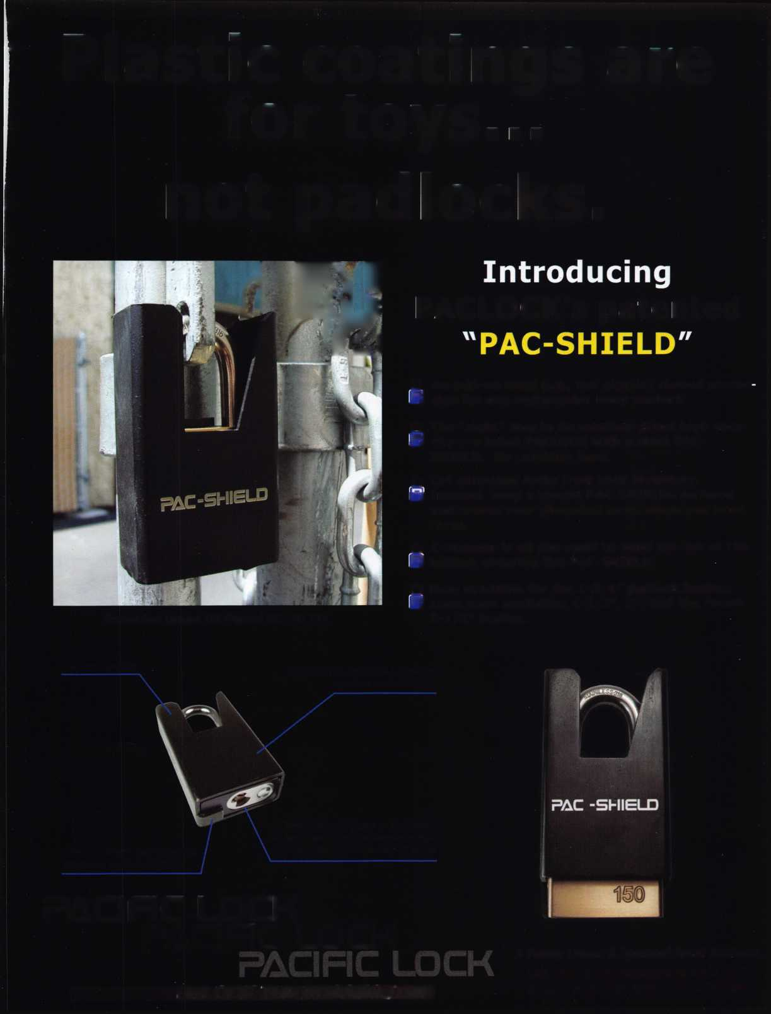

"PL" Laminated Series

For years people have overlooked the fact that most  
laminated padlocks are prone to various types of  
simple and effective attacks like bypassing and shim-  
ming. The reason for this is that the majority of lami-  
nated padlocks are lever-locking. Stop buying

padlocks that are  
lever-locking! It is  
a simple fact that  
dual ball-bearing  
locking padlocks  
are far stronger  
and far easier to  
operate than lami-  
nated padlocks.

At ALOA this year  
PACLOCK intro-  
duced its new Pa-  
cific Laminated  
"PL" Series of lami-

nated padlocks. These laminated padlocks are dual  
ball-bearing locking and have a solid brass actua-  
tor! (See Figure 1) The PL Series cannot be by-  
passed nor shimmed and are more than 60%  
stronger in a pry force test than the leading lever-  
locking padlock. More importantly, though, is that  
the ball-bearing design means these padlocks are  
far easier to close than the leading lever-locking  
padlock. The PL Series means there is no more shov-  
ing the padlock against a wall to get your padlock  
to close.

Keep in mind that these laminated locks are not just  
stronger than the competition, but they have all the  
bells and whistles. The locks have a dual-injection  
molded, custom fit bumper that rivals any other man-  
ufacturer out there. No "cheap Chinese bumper"  
here. The lock has a brass plug and die cast shell  
as spec'd by the US military (drilled 5-pin). The keys  
are brass and the lock is nickel plated. No expense  
spared here.

These laminated locks are available as a direct sub-  
stitute for the Master Lock® line of laminated pad-  
locks. Moreover, the Keyed Alike (KA) versions of  
the PL series will use the Master Ml keyway, spac-  
ing, and bitting. Or, if you prefer to move to a re-  
stricted keyway then you can choose from any of  
PACLOCK's restricted keyways. These keyways, by  
the way, are interechangeable between the lami-  
nated locks and the solid-body locks by PACLOCK.  
Use the more affordable PL series in low security  
areas and the higher security solid-body padlocks in  
areas where they're needed. But feel comfortable  
knowing that all of these locks are using the same  
keys and keyways.

The PL1 (1-3/4" body) is available now. The PL3 (1-  
1/2" body) is expected to be available in March  
with the PL5 (2" body) available in July.

"XIC" Hockey-Pucks

The combination of your SFIC or KiK cylinders with  
the hockey-puck padlock is like combining peanut  
butter and chocolate. Their patent pending "XIC"

hockey-pucks have a  
unique sleeve design  
that isolates your SFIC  
or KiK cylinder from  
the hockey-puck body  
itself. The "IC-Sleeve"  
accepts 5, 6, or 7-pin  
Interchangeable  
Cores while the "X-  
Sleeve" accepts 6-pin

door cylinders like Schlage, Marks, Medeco, or Bi-  
Lock. With the XIC hockey-pucks you can finally use  
your Schlage Primus cylinders or your Best 1C Cores  
in the toughest padlock design ever made ~ the  
puck-lock.

"Your Logo, Your Locks"

PACLOCK's custom laser engraving program is the  
most robust, efficient, and affordable program bar

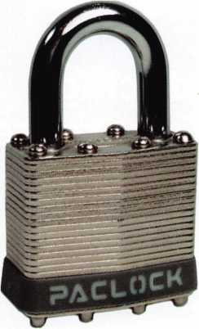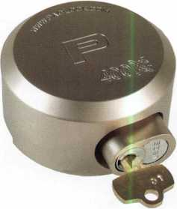

**6**

Keynotes • December 2007

none. Called "Your  
Logo, Your Locks," the  
program literally trans-  
forms "their" padlocks  
into "your" padlocks.  
Unlike the competition,  
Pacific Lock does not  
have their brand name  
stamped anywhere on  
"your" locks. Instead, the  
Pacific "P" logo is left off  
and what they use for en-

graving are blank or "no-logo" padlocks. That  
leaves the entire real estate of the padlock available  
for your use ~ front, back, sides. No other manufac-  
turer does this.

What's more, PACLOCK charges no setup fees or digitization fees. Their per-lock engraving costs are the best in the industry and they have no minimum orders. Lead times are generally three to five busi­ness days even on custom engraving orders. Three to five WEEKS is what you are lucky to get with the other manufacturers.

Generally speaking there are no limitations on fonts, sizes, logos, or anything else. So long as your logo or text will literally fit onto the padlock then they can do it for you. Want Chinese characters? No prob­lem. Have a Spanish requirement... no problem. Russian, Thai, Swahili... no problem. They can make it happen.

Tired of using your hammer and a die set to punch in unique serial numbers on all of your padlocks?

For less than a buck let PACLOCK do it for you ~ they'll insure that you never receive two padlocks with the same serial number.

"PAC-SHIELD"

In July of '07 PACLOCK introduced another revolu­tionary idea ~ the "PAC-SHIELD." Quite simply the idea is to add a steel, shrouded protective layer to

any rectangular body padlock. Keep a couple on  
your shelf and add them when needed... quit buy-  
ing expensive, shrouded padlocks.

The PAC-SHIELD is simply added by slipping the  
shield over the padlock and hammering down the  
tab at the bottom (See Figure 2). The tab is specifi-

cally positioned to  
allow rekeyable  
padlocks to be  
rekeyed with the  
PAC-SHIELD in  
place.

Tired of buying  
plastic coated steel  
padlocks that crack,  
then rust and then  
stop functioning  
over time? Buy a  
brass PACLOCK in-  
stead (like their

150 Series that comes with a 316 Grade Stainless  
Steel shackle standard) and the PAC-SHIELD, put  
them together, and now you truly have a high secu-  
rity, highly weather-proof padlock! No plastic to  
crack open here!

The Future of Padlocks

While many things in life are unclear, what has be­come clear over this past year is that PACLOCK is the future of padlocks. The company prides itself on being a small business that caters to the locksmithing industry. Its products and services are uniquely tai­lored to preserving a locksmith's business, improving the locksmith's cash-flow, and ultimately making lock­smiths more money. PACLOCK considers itself to be a valued partner to the commercial and institutional locksmith. For more information please call your local distributor, visit their website ([www.paclock.com](http://www.paclock.com)), or call them directly at 888- 562-5565.

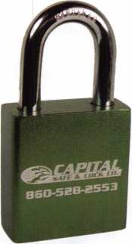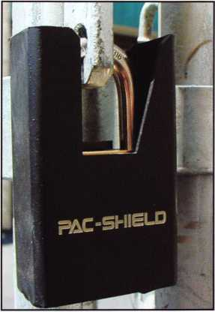

Keynotes • December 2007

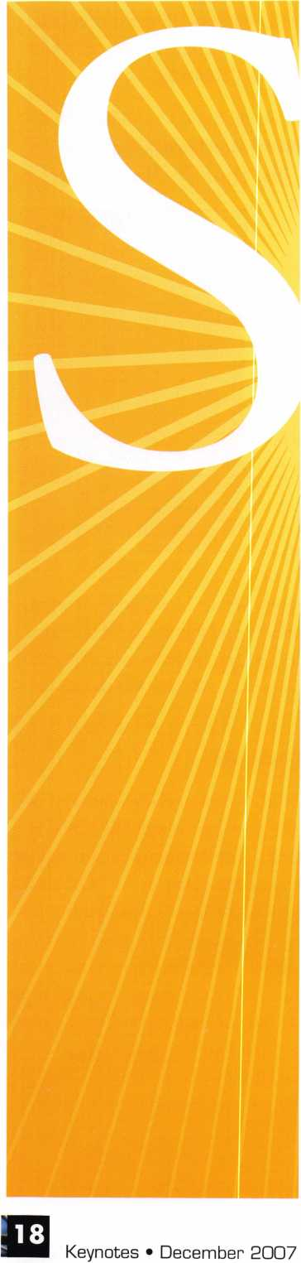

**MEMBER\***

potlight

Welcome to our new monthly feature! Each month we will highlight a current ALOA member & their lockshop with a short bio and in-depth questions. To be considered or to recommend a fellow ALOA member please send an email to [margarita@aloa.org](mailto:margarita@aloa.org).

**SECURITEX**

locksmith

John Arnold  
Key Express  
www. key ex p r ess. co m

My Carrollton, Texas shop.

1. Tell us about your background in security and your experience in locksmithing.

John: I have been working in the industry for over 25 years. I have learned from on the job, ALOA, Texas Locksmiths Association, and suppliers. I try to read my Keynotes every month.

1. How long have you been a member of ALOA?

John: Since 1984, almost 24 years!

1. How long have you had your business?

John: Since 1988

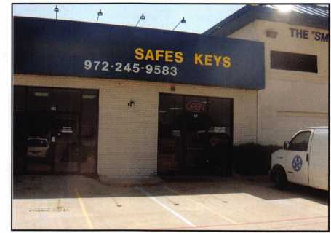

1. Explain what your position is at your business.

John: President, locksmith, general bathroom cleaning is probably a good description. I probably spend too much time working with the locks and security systems, but it s my nature. I clean the bathroom to show my employees I would never ask them to do something I am not willing to do my­self.

*“I hate doing the same  
thing over and over;*

*I found a profession  
that doesn’t require  
me to do that!”*

1. What was your starting point in security?

John: I got into locksmithing when I was in college. I needed a part time job and saw a help wanted sign on a key shop. I didn’t even know what a locksmith was, I just figured I could cut keys. 25 years later I am still I keep learning new things everyday and still love my job.

1. How many employees does your business have?

John: 12 counting my wife, my office personnel, and myself.

1. What are the changes that youVe noticed in the security technology recently?

John: I think the lock bumping craze has been the story of 2007. Some think it has been blown out of proportion, but I think it really has been good for the general public to be aware that their 10.00 lock is very open to picking and bumping. The problem is not new, but it makes our job easier when we ex­

plain these security flaws to our customers. I am concerned about the new self-changing locks; they seem to be well made, but I question how they will hold up. I see more value priced electronics coming out, but I have yet to be convinced they are good products. I see the CCTV market exploding. I think we have a challenge competing with cheap products more than ever. I have found myself sell­ing some value priced items and lived to regret it.

1. What do you see as the future of security and where do you think are we headed in today!s age of technology?

John: I think we’ll see more of the wireless elec­tronic locksets. I believe some of the lower cost elec­tronics will finally become more reliable.

Locksmiths are going to have to smarter than ever in the future about selecting products they will sell and service. Our future will depend on it.

1. How do you stay informed about new products and security techniques? i.e. magazines, conven­tions, classes, etc.

John: I usually attend ALOA, and I read the maga­zines when I can. I am 1st Vice President of Texas Locksmith Association, so I am involved in their convention. I was President of Associated Lock­smiths of North Texas, I really get a lot from the monthly meetings and talking to other members about the issues they are encountering. I think I get the best information from the local association. We meet monthly and I hear about issues as they occur.

1. Do you find that other locksmiths in the Carroll­ton area work together on referrals and work flow?

John: We cover a large service area. We can’t always get to everyone. My dispatcher has list of locksmiths from the local association. We refer calls based upon area and expertise. I probably refer 10 calls a week to my competitors. We get a lot of referrals back also.

Keynotes • December 2007

1. How has life changed for you as a security pro-  
   fessional in the past year?

John: I have found it easier to sell our core prod-  
ucts as a result public awareness.

1. How do you sell security to the public?

John: We use different mediums to get teir atten-  
tion; we can’t wait on the Yellow Pages to send us

enough good cus-  
tomers. We contin-  
ually are looking for  
new ways to reach  
our customers. I  
make sure cus-  
tomers understand  
that we are licensed  
and point out the  
many certifications  
my technicians pos-  
sess.

1. What do you like  
   most about your  
   job?

John: I hate doing the same thing over and over; I found a profession that doesn’t require me to do that!

1. What advice can you give to an aspiring secu­rity professional?

John: Find a company willing to train you and send you to lots of classes and conventions. Be willing to work hard and long while learning. You will be able to take advantage of this once you have done it while. The guys who never get it are the ones that don’t want to pay their dues.

1. What do you think is the biggest obstacle fac­ing security professionals, if any?

John: Someone else does almost everything we do. We have to keep promoting our profession as the place to turn for real security and service. We must differentiate our profession.

1. Can you remember your first big security job?

What can you tell us about it?

John: I got a job to master key replace the locks  
on a 600-unit apartment complex, and they  
wanted it done immediately! I got 5 or 6 lock  
companies to come out and help. We completed  
the job in 2 of the longest days of my life. I

learned a lot from that ex-  
perience. I made money  
off that job, but it wasn’t  
enough! I did get a lot of  
satisfaction from the co-  
operation of the other  
locksmiths.

1. Have you personally  
   run into issues with  
   bump keys which have  
   recently been featured  
   in the news? How do  
   you feel about this  
   issue?

John: I think it is making

the public aware of a problem that has always been  
there. I think the bump key is a little over blown.

It is just another form of lock pick. They caught  
the “bump key burglar” here in Carrollton, they  
actually were using regular lock picks.

1. How do you feel about the issue of phony lock-  
   smiths? And how do you think this affects the  
   locksmith industry?

John: It is a good example of why we need to be  
licensed. They are destroying our image and our  
industry. Our associations must say on top of this,  
it is our biggest challenge.

1. What are some ways that you ensure your cus-  
   tomers of your trust and skill as a locksmith?

John: We let them know we are licensed. We al­ways lubricate all locks and double-check our work. We never ignore an issue at a jobsite, I point out all the problems see, even if I am not there for that problem.

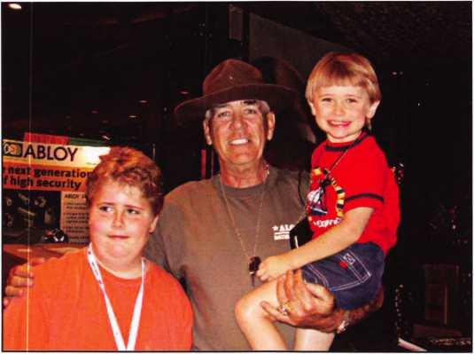

My kids at ALOA in Baltimore.

Keynotes • December 2007

1. Name a few things that you think lock­smith business owners should do to help their businesses prosper and grow.

John: Get involved with your associations, keep up your professionalism, and keep seek­ing information on new products.

1. What is your favorite place in Carrollton, Texas?

John: Corvettes of Dallas. They are my neighbor and I fear one day I’m going to see a yellow Corvette out there and I’ll be getting a new service vehicle.

My downtown shop becoming a pawn shop  
for the TV show Prisonbreak.

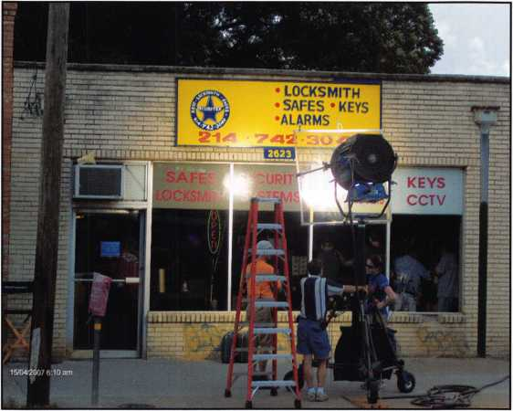

***State-of-the-Art Terminal & a Contactless Reader***

*+ 24-7*

***Customer Service***

***The Best Credit Card Equipment***

***Is Your Bank  
Not Giving You  
A Loan?***

***Rates starting at***

*GET CASH NOW*

**NorthAmerican**

BANCARD

***TO GROW YOUR BUSINESS!***

**Call Today And Receive Cash As Fast As 72 Hours**

***+ Accept Checks***

***Like Credit***

**1**-**866**-**481-4604**

JfflLCAPITAL/b- CS3 MERCHANTS

A wholly owned subsidiary of North American Bancard Inc,

Keynotes • December 2007

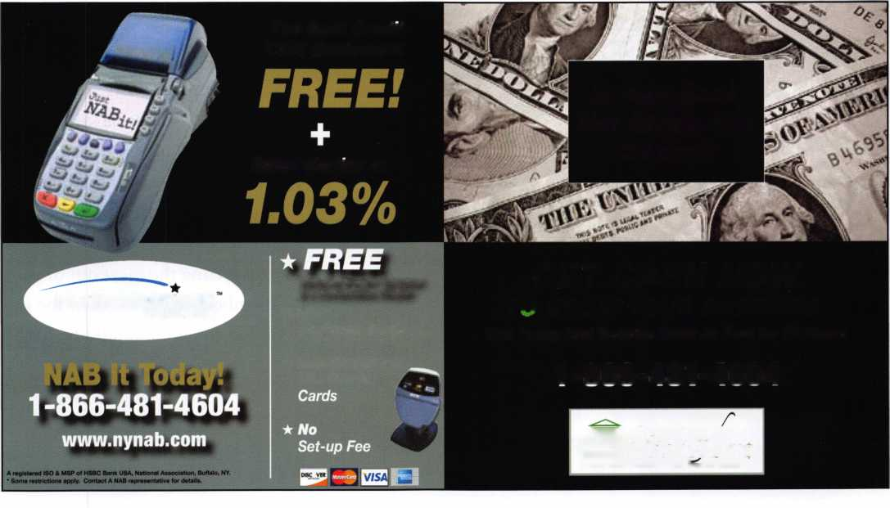

**Time To Renew - What’s My ROI? (Return On Investment)**

By Ellen McEwen

It’s that time of

year when yo  
will be receivin

your membe

ship renewal i

voice and if yo

are like many

us, you will set

aside and won

der "why shoul

I renew?” Wh

is the ROI on  
investment?

M



For many of you, you know ex­actly the ROI you receive from your membership and so renew­ing is a simple decision, but for those of you who pause ask your­self, “What do I expect from my membership?”

Did I participate in any educa­tion or networking opportuni­ties? Have I gained any new knowledge about my industry or fellow professionals in Keynotes? Do I periodically visit the ALOA website for the most recent in­formation? Have I taken advan­tage of the more than 200 classes that ALOA presented this year to advance my career? Have I taken advantage of any of the other benefits such as “Find A Lock­smith” to promote myself to the public for free? Or has my state proposed legislation that will not

be beneficial to the locksmith professional?

If you answered yes to any of these questions, then you are in­deed taking advantage of your membership with ALOA, but are you taking full advantage of every benefit that is available to you.

Remember membership with any organization is a two way street, the ROI is based on how much you put into having a membership as well as what is available to you as a member. So, for forty-three cents a day are you getting the most out of your membership? If so, then the de­cision to renew should be easy.

Thank you for renewing! Be on the lookout for more exciting and unique benefits in 2008!

Keynotes • December 2007



**Chapter and Affiliate Updates**

**If you believe there is value to being part of an association who is working towards bettering your industry, then don’t forget to support your local ALOA Chapters and ALOA Affiliate Associations in your area.**

Welcome to the newest ALOA Chapters and Affiliates:

DC Chapter (currently forming)

Chairman: Lester Brodsky,

West Tennessee Chapter (currently forming)

President: Vince Formon, CML, CPS

L,

Locksmith Association of San Antonio

President: Wanda Robbins

New Hampshire Locksmiths Association, Inc.

President: James Broadhurst

Northwest Locksmith Association

President: Ken Clapper

South Carolina Locksmith Association, Inc.

President: Jeffrey K. Owens

For the most up to date listing please visit [www.aloa.org](http://www.aloa.org)

ATTRACT NEW BUSINESS! ACCEPT VISA. MASTERCARD, DISCOVER & AMERICAN EXPRESS CARDS Increase Sales, Eliminate your Risk, Improve Cash Flow - Cellular Technology Captures Funds On-The-Spot! MERCHANT ACCOUNT WITH FREE TERMINAL FOR ALL BUSINESSES - ONLY $ 345. FOR ACCOUNT SET-UP New Wireless “Check Conversion” Now Guarantees No Bounced Checks, No Driving to the Bank with Deposits! DEPOSITS WIRE-TRANSFERRED TO ANY BANK, ANY CHECKING ACCOUNT. EVEN PERSONAL ACCOUNTS OK National Promotions PayProTech LLC Registered ISO/MSP of Chase PaymentechSolutions

Keynotes • December 2007

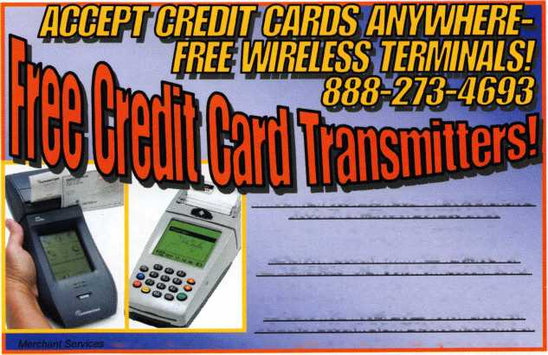

**Beloved** Staff Member Retires

26-Year ALOA Staff Veteran Created a Legacy of Love for Locksmiths

Like a stream, gently lapping at the shore, Mary has changed  
the working landscape at ALOA. In the calm and gentle way  
of water, she has initiated projects and made changes that will  
forever influence the way this company does business. In  
2001, to recognize her many efforts and years of dedication,  
Mary was the only staff member ever to receive an Honorary  
Membership designation.

Legislative Affairs Director, Tim McMullen had this to say,  
“When I applied to work at ALOA, Mary was the one who  
set up the interview. We hit it off right then over the phone.  
We spoke about the office and what it was like to work there.  
She even gave me the inside scoop to call the Executive Direc-  
tor "Bill” or “The Colonel" even though his first name was  
Charles! She was then, as she always is, an approachable, car-  
ing, energetic, “the-sun-came-up-this-morning-so-what-possi-  
bly-can-go-wrong-today?”person. She is the glue that holds  
this organization together, and her presence at ALOA will  
have a lasting effect for years to come."

Mary Shines at the Show

Mary is most recognized for her work at Registration. “All of  
the members who come to registration havdto«get#a big hug  
from Mary May. She always has a big smiie*$ur.tKenj*She asks  
about their families. She knows everyone?* *says#*Jeanne Mims,  
Convention and Meetings Manager. #*# ; *

Twice a year for 26 years, Mary May has been  
the face of ALOA at registration. Her pres-  
ence is calming and kind. “Sometimes,

before I

With as many conventions under her hat as hairstyle changes, Mary May has broken many hearts by announcing her retirement from the Associ- mk ated Locksmiths of America.

Ms. May came to work for ALOA  
*§ in 1980 as a Membership

Clerk and has worked in  
every area of the organiza-  
tion from computers to con-  
ventions. She will retire at the end of 2007 as the Director of  
Member Services. In that time, she has met thousands of  
members and made countless positive changes to the ALOA  
organization.

Some of you may be doing the math and wonder how, having  
started at ALOA in 1980 she logs 26 years instead of 27. vWhere did the lost year go? Mary once quit working at ALOA'  
during an uncertain time. As the story goes, she felt unsure if  
she was on track with what she should be doing or accom-  
plishing to get where she wanted to be in her life. After a year,  
she came to her senses and returned jtq ALOA. Her friends and  
coworkers can only hope that history repeats itself now. “We  
don’t want her to leave!” safd Robert Stafforjj/CML.

Mary’s biggest contribution to ALOA has been her willing  
spirit and caring soul. She truly adores locksmiths and ALOA  
members. In dyery decision, she puts the members’ needs first.  
She is a friend to everyone and always seems to know the wis-  
est course of action. Her knowledge about the organization is

and she is always willing to do what it takes to get the

vast

job done.

'¥$• • • SHI

“Everybody loves Mary! Our members know they can always call her for a quick answer. I think most of them just call to hear her friendly voice, though.” says Betty Southerland,

scheduled to work, I go

down early to registration to hang out  
; with Mary and help out. It sets a good

tone for my day to see a smiling face early in the morning”, says Margarita Garza, Graphic Designer. ^one#trip that I look forwapd^^^^^^^^^^^Annual



can visit

SAFETECH Convention. Working side by side with Mary at these conven-  
tions over the years has truly been a pleasure. It will definitely not be the same  
without her.”, says Gregory Jackson, Director of Information Technology

At the 2007 ALOA Convention and Security Expo, Mary May received the  
50th Anniversary ALOA President’s Award at the Meeting of the Membership.  
Then ALOA President Bob Mock delivered an emotional speech as he pre-  
sented the award. “Everybody knows and loves Mary May.” he said through  
tears of gratitude and went on to describe Mary’s richly-textured career at  
ALOA. “At one time or another, she has joyfully helped just about every mem-  
ber in the organization.”, he said.

At the presentation, Mary was described as kind, capable, and a true woman of  
substance. There wasn’t a dry eye in the room as Mary’s name was announced.  
Mary was shocked to win the award saying, “I am totally surprised and hon-  
ored. I have made some of the best friends of my life here.” She also said she  
should have realized something was going on when nobody asked her to order  
the award as she usually does.

There’s Something About Mary

It is well known that locksmiths are independent thinkers but this is one sub-  
ject on which aloa members wholeheartedly express their adoration, gratitude  
and concern. }

Bill Smith, NC Director wrote, “Mary-Mary-Mary—who said you

tire ? Why should a 30-year-old girl even think about retirement?

WOW.. .time moves pretty fast, doesn’t it ? I can vividly remember meeting  
Mary for the first time. I had talked, on the phone, several times before meet-  
ing her face to face. Without any introduction, we immediately knew each

other. She is yet, that same wonderful, beautiful, radiant person that I met at

Chicago convention. I even got to know her dog (that I had never seen),

is one that can carry on a conversation with anyone at anytime. I’ve see:

of the problems that Mary has encountered with ALOA. Sometimes a member

was upset over something and there was no apprent solution. Mary always

anaged to come up with one, usually making sure the member

ut remaing fair to everyone else. Even when there was a language

problems got solved. Calm and Cool, that is Mary. I’ve alwayl felt that a con-  
vention was like a family reunion. A big part of that family reunion was a fa-

vorite “sister”, Mary. I, for one, am gonna miss this important fixture of

ALOA. I hope Bill Gibson can find (half dozen) people to take her place.

IOD bless you throughout your retirement, Mary. Don’t forget to show up at

some of the functions now and then.”

1/

9j5age has been added to the ALOA websites where

(id view comments and farewell messages to Mary

r. aloa.org).

22Aassv sieves /Aee/Za <)ezy  
% ^ yoes/-/ye, 27tvs//

ya^Z^vy, Jv Z7?s/y .

^A^es J^/yiAs^yesis^  
asZZ/fZAiZyeeaZ ceeyiesa -  
zzve ^22z, ^A27272lA?f ZZ  
iZ *sishv* ZssieAussie Za Zassi  
zAy/aye Zv is siesv cAyiZes ey/

ss/y Zy2. (WAesi 2 cassie Za

*f* aye/ss/y

a/ess/asi esiZesZsy /As ive/A-  
y/sse, 22assi siviv aysasaZssivZ/ee

' A/yyvassay ivZZAA/Zy/sie e/ys/saZaZZss/  
AA Zsa^ /eesi a asesa/es^s/\**0*/*16*. 22 Aa£ aA-  
S/veeZvis ZAe tyyieeZasiZZy Ze a/e/Ay/is as/s/  
Aesve Avsne zy/z/eyTwxZy/eey/Ze 22Azs/e eves  
ssieZ, ss/sssy o^ivAvsn 22Aave evssie Za cesi-  
cUi/^yies^siaA^Zesiv2. .227s Z/sZ 22asn ss/sh)/  
ysaZe^AA

22z Zxssy Ae-lZse ZZ/aZA7ZAZ222/ ivZAeesi-

ZZsiae Zayse/v asie/yiseyies Zsi zAZ assies -

Zsyyise^Msosi /y/jssasZZy.

22aA222z/ave eessie Za Awiv

2/aaZAyva

^evesZoAZZy Aaeee&X, AeaAA

?aee.

^ZffiZasiAx (Xa ssiaeA^s

yeas JsyyivsZ ZAseayAnaZ

ZAyeasX 22ivZA/cAesZ)AZAe

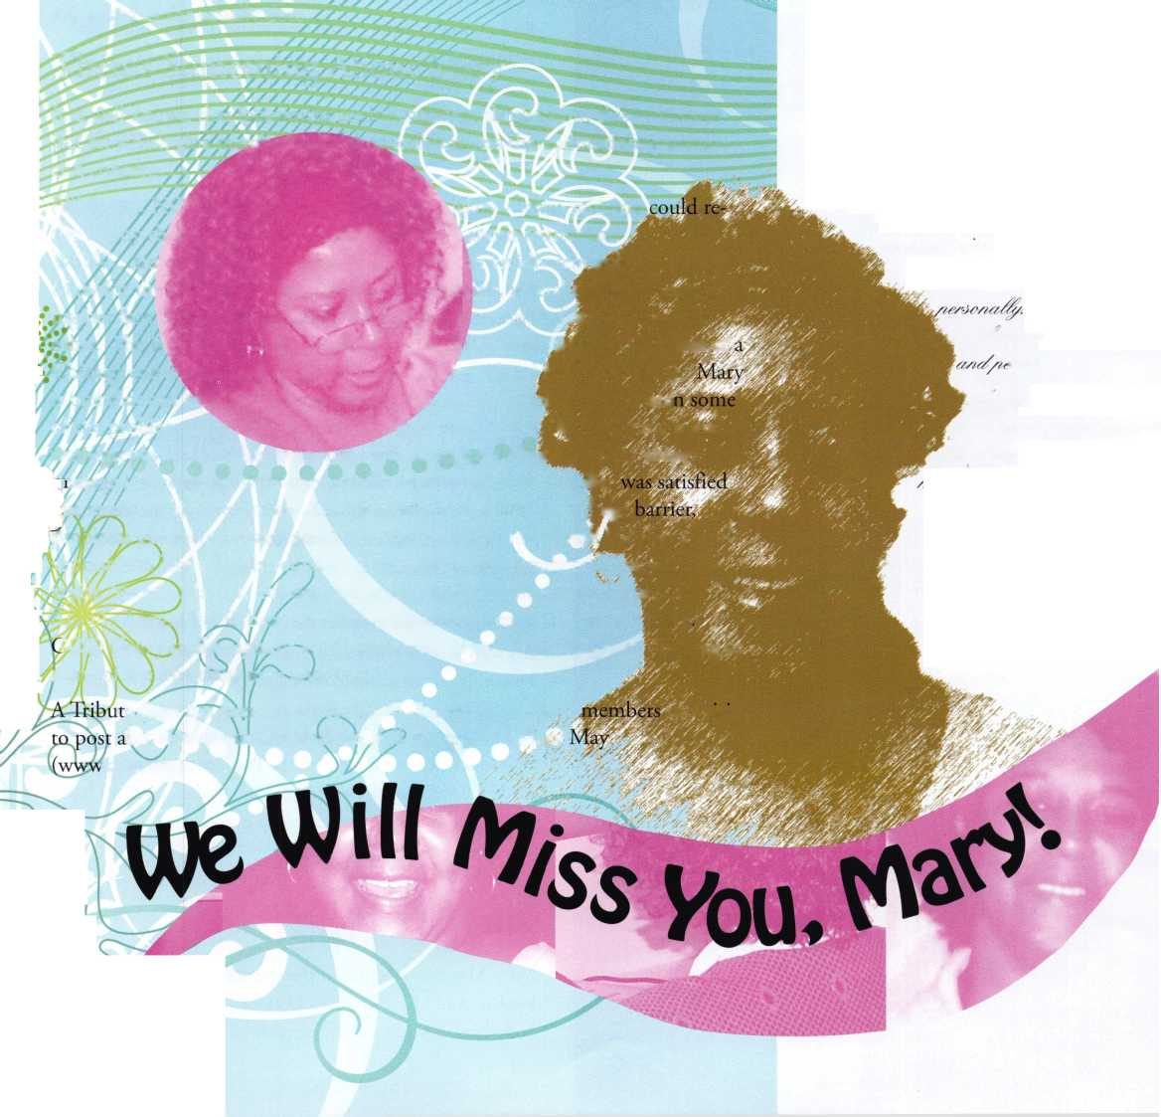

Mary adopts her beloved dog, “Sweet Pea”

Mary is awarded with the title Honorary Member”

Mary’s introduction bio was featured in the 1982 issue of Keynotes

1980

Mary’s hard work is rewarded with the 50th Anniversary ALOA President’s Award at the 2006 ALOA Convention and Security Expo in Vegas

2007

Mary ends her

26-year long

career at ALOA

Mary begins her career at ALOA

1992

**Notes to Mary**

Dear Mary,

I remember quite a while back (6 years) sitting at regis­tration with you at my first show I was scared to death about this new endeavor I had taken on, not knowing what was ahead of me, plus having just buried my mother. Your help got me through. I’ll never forget the encouraging words and the soft way that you spoke of your own mother, telling me that time would heal the sorrow and that every new job is difficult in the begin­ning.

You were right.

So as you embark on this new stage of your life I am sending you back those same words of encouragement in a soft voice.

Thank you for everything you have done to help me do my job better with ALOA.

You will be missed.

Love,

Kim Hammond

Director of Advertising and Booth Sales

**Mary’s Memorable Moments**

^ A road-rage incident occurred in Orlando back in the late 1980's. It involved a former staffer; I can't go into details, but there are those out in ALOA-world who know what I am talking about!

% A former board member that was related to a federal secu­rity official once arranged a tour of portions of the White House. It was amazing to me then, a young country girl.

^ The most memorable: ALOA 2006- when then President Bob Mock presented me with the President's Award. It made me feel like all the struggles and challenges that I had endured throughout the years were not in vain.

**Simple and True**

Mary May has to be one of the sweetest persons I have ever known. And I have known a LOT of sweet people.—John Soderland, CML, CMST, Secretary

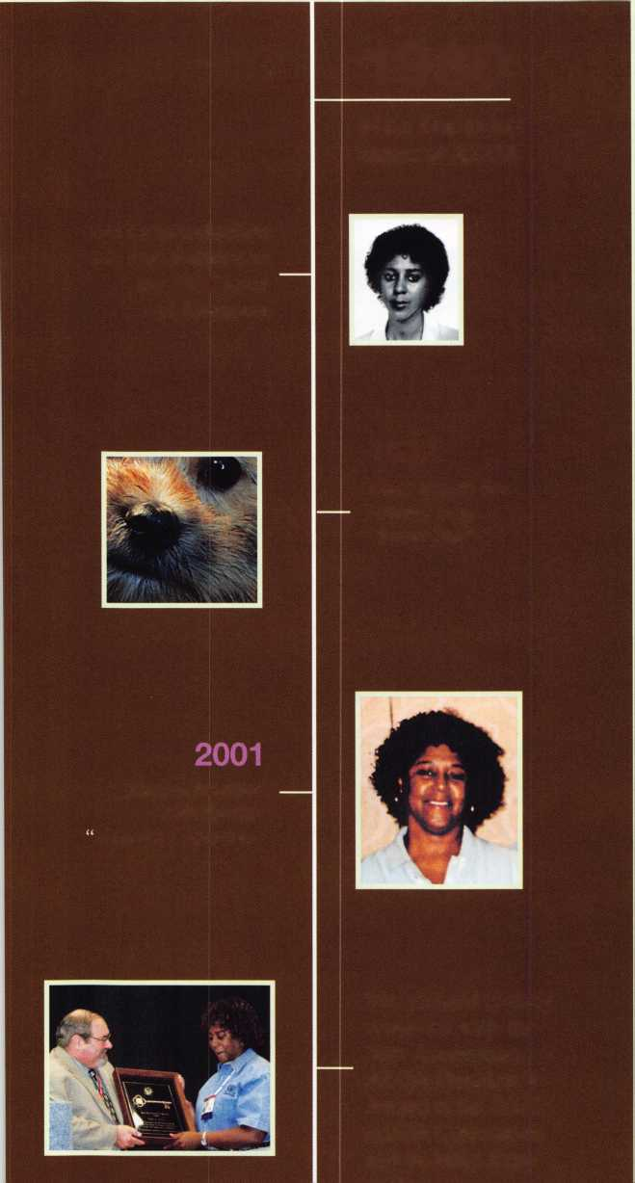

Safe & Vau/fTechnicians Assoc.

**TECHNICIANS ASSOCIATION** r

**BRIGHTEN** YOUR FUTURE. **HIGHLIGHT** YOUR SUCCESS!

'cover ie installa- !nce and opera­tes and vaults at ; from novice to expert. The "only chance to get world-class tly, education and meet with the Te when it industry’s top distributors and !cition. New de- manufacturers is at the 2008 Fs spring up each Safe & Vault Technicians 'making top-notch safe Convention & Trade Show.

**SAFETECH 2008**

**March 31-April 5, 2008  
Riviera Hotel & Casino  
Las Vegas, Nevada**

**[www.savta.org](http://www.savta.org) • 214.819.9771**

SAN DIEGO CALIFORNIA

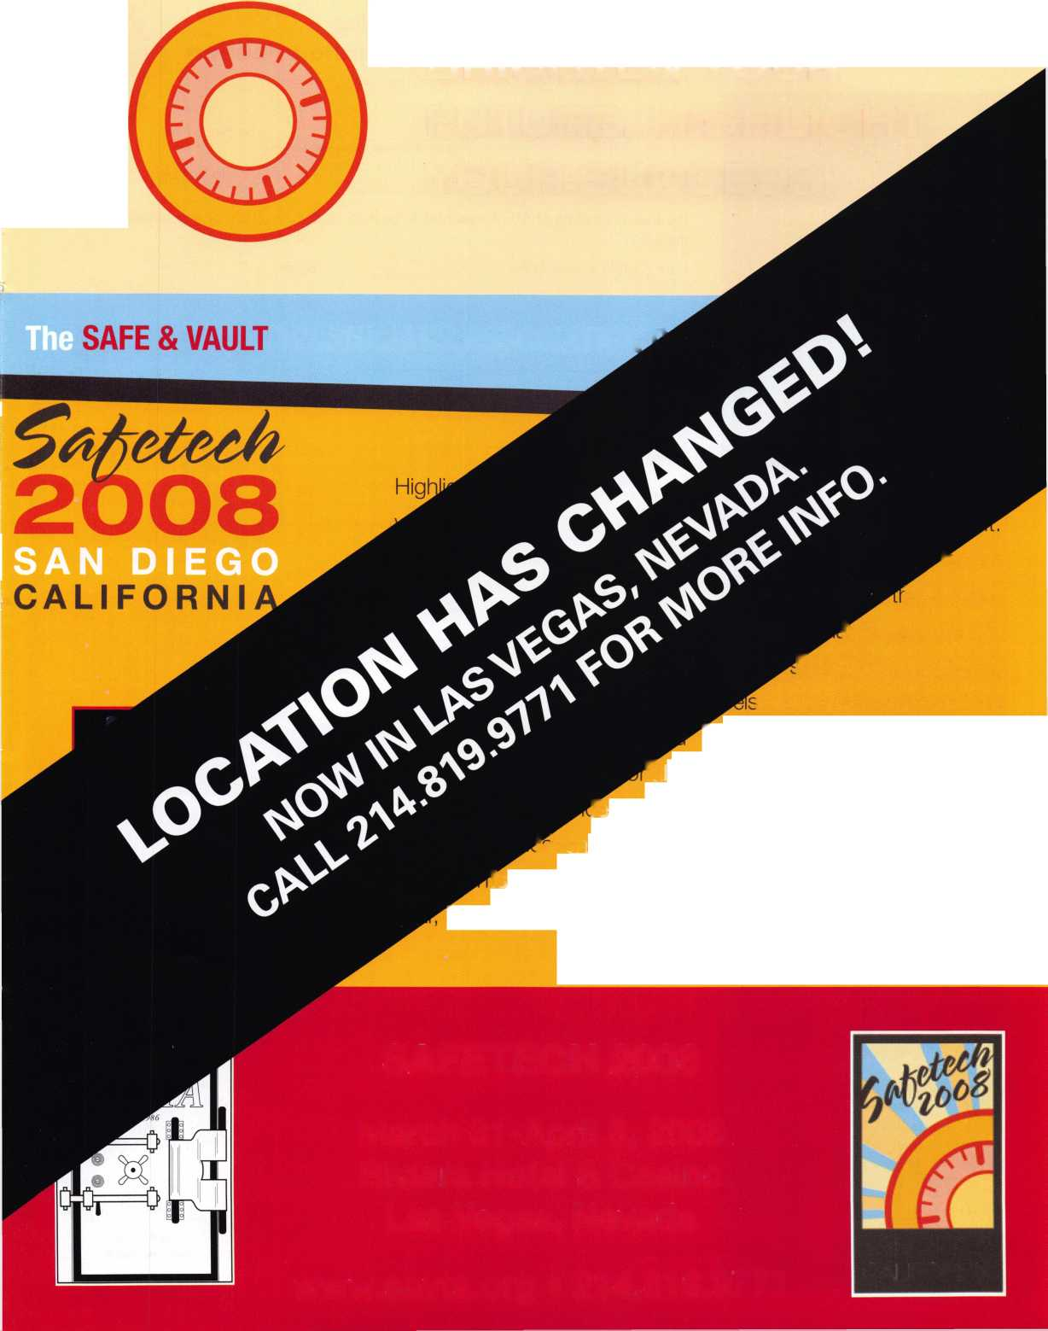

BOARD

nominations

What ALOA Board Po­sitions Are Open and Where Am I Qualified to run?

There are currently six regional di­rector positions open for election in addition to the position of Secretary. ALOA members elect the directors from their own regions.

Only ALOA members from a region are eligible to run for the open posi­tion^) in that region. Only members from a nominee's region can vote for their regional candidates.

Members from any region can vote for the Secretary.

Candidates for director positions must have been active ALOA mem­bers for a minimum of three years to be eligible to run. Candidates for the office of Secretary must have also served on the Board within the prior three years to be eligible.

The following vacancies will exist for the election to be held before the ALOA 2008 Convention:

Secretary 1 position

Northeast 2 positions

South Central 1 position

Northwest 1 position

International 1 position

Associate 1 position

If you have any questions, please contact John Soderland at:

Associated Locksmiths of America, Inc.

Board of Directors Nomination Petition

Please print legibly or type. This form can be reproduced if needed.

I, the undersigned, request that

k I A

be placed on ^

the ballot for

(name of nominee and member number)

for the election to be held at

(position for which individual is being nominated)

the special meeting of ALOA members to be held on May 9, 2008 or any adjournment thereof.

I am eligible to vote in the region.

t

PRINTED NAME MEMBER # SIGNATURE

2

PRINTED NAME MEMBER # SIGNATURE



PRINTED NAME MEMBER # SIGNATURE



PRINTED NAME MEMBER # SIGNATURE



PRINTED NAME MEMBER # SIGNATURE



PRINTED NAME MEMBER # SIGNATURE



PRINTED NAME MEMBER # SIGNATURE



PRINTED NAME MEMBER # SIGNATURE



PRINTED NAME MEMBER # SIGNATURE



PRINTED NAME MEMBER # SIGNATURE

11

PRINTED NAME MEMBER # SIGNATURE

12

PRINTED NAME MEMBER # SIGNATURE



PRINTED NAME MEMBER # SIGNATURE



PRINTED NAME MEMBER # SIGNATURE



PRINTED NAME MEMBER # SIGNATURE



PRINTED NAME MEMBER # SIGNATURE

(414) 327-5625 or e-mail [secre- tary@aloa.org](mailto:secre-tary@aloa.org)

On this page you will find the re­quired nomination petition and on the following page, the board com­mitment form.

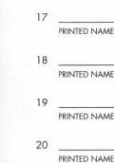

MEMBER #

MEMBER #

MEMBER #

MEMBER #

SIGNATURE

SIGNATURE

SIGNATURE

SIGNATURE

The number of signatures required for each position is as follows:

Secretary

Northeast

South Central

Northwest

International

Associate

25

18

6

3

6

1

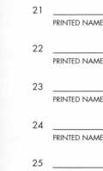

MEMBER #

MEMBER #

MEMBER #

MEMBER #

SIGNATURE

SIGNATURE

SIGNATURE

SIGNATURE

PRINTED NAME

MEMBER #

SIGNATURE



YOUR COMMITMENT TO ALOA BOARD SERVICE

(Please read carefully and sign where indicated.)

The ALOA Board governs with emphasis on organizational vision rather that on interpersonal issues of the Board; encourages diversity in viewpoints; focuses on strategic leadership rather than administrative detail; observes clear distinction between Board and Executive Director roles, makes collective rather than individual decisions; exhibits future orientation rather than past; and governs proactively rather than reactively. (If you were not supplied a copy of the ALOA Board of Directors Governance Policy with this document, you may obtain one by contacting the ALOA headquarters office, or visit [www.aloa.org](http://www.aloa.org).) The responsibilities of an ALOA Board Member include contributing a moderate amount of personal time, and a significant degree of professional guidance and expertise to the or­ganization.

You will be expected to come to Board Meetings and the Annual Membership Meeting. You will need to be prepared to sensibly dis­cuss matters of great importance to your profession and participate in setting policy as part of a governing body. Your course of action during your tenure on the ALOA Board should be guided by fair minded, constructive goals pertaining to matter of consequence for ALOA and for the industry. Your contributions are expected to benefit ALOA as a whole taking individual member rights and concerns into account, but free of the taint of partisan politics of personal gain.

On a practical note, ALOA Board Members are expected to behave and dress professionally at all times, especially when actively rep­resenting the association. ALOA Board Members are required to participate in three Board meetings per year, of three or four days in length, one each fall, spring, and one during convention, in addition to the Annual meeting, which is also held during convention. In­coming Board Members are also required to attend Governance training classes and events during convention. Board Members may also be asked, on a voluntary basis, to represent ALOA at related local, state, or regional functions, including serving in the ALOA booth, and otherwise promoting ALOA. When travel is required for a Board Member, expenses covered by ALOA includes lodging, travel, and a reasonable per diem. The Board has stipulated that assigned travel will be reimbursed at the lesser of the 30-day ad­vance tourist class airfare in effect at the time of travel, or the current per-mile rate for travel by personal automobile. Spouse expenses, including extra room charges, etc. are the individual's responsibility.

• • •

I have read and agree to adhere to the ALOA Board of Directors Governance Policies. Furthermore, I understand the above responsi­bilities of an ALOA Board Member, and agree to commit my time and energies as needed. I certify all of the information contained on this form and supporting documentation to be true and complete.

Candidate:

|  |  |
| --- | --- |
| Name: | Address: |
| Member #: | Phone: |
| Signature: | Date: |
| Membership Status: Employer: | Active Probationary Retired Life Associate |
| Name: | Address: |

Please attach a recent photograph of yourself along with a 150 word or less biography and retain a copy of this form for your own files. This form and all supporting documents must be received no later than February 1, 2008. Mail, e-mail or fax to: (If faxed, photo can follow by e-mail or mail)

Nominee Profile

Secretary of the Board of Directors  
John W. Soderland, CML, CMST  
5132 West Howard Avenue  
Milwaukee Wl 53220  
(414) 327-5625 • Fax: (414) 327-4366  
[Secretary@aloa.org](mailto:Secretary@aloa.org)

Starting Safe Deposit Work

By Greg Perry, CML, CPS

Safe deposit work can be frustrating and difficult without the right knowledge and tools.

It is a small specialty niche market in broader field of safe work and broader still, locksmithing. Safe deposit work also has some legal issues, maybe not unique, but more common to safe deposit work. Unpaid rents, deaths, court orders, lost keys to boxes and even banks closing needing the balance of the boxes opened are common. Knowledge gained by the school of hard knocks, by you on the job, in front of cus­tomers is a poor way to learn. Instead take a class at the SAVTA or ALOA convention or one of the many offered by local associations. Then go back to your shop and practice the techniques learned. But knowledge is only half the equa­tion; proper tools will make the job go much easier. Even if you never plan to work in a bank, safe deposit locks have been used in safes and other cabinets. They also are quite common in hotels and motels for guest storage. A little knowledge about them can expand your customer base. Let’s take a look at the design of the locks and some of the tools available and the basic techniques for opening and servicing safe deposit locks. In the future we will explore the construction and vul­nerabilities of some of the locks individually.

Generally there will be two noses or sides of the lock, al­though single nose designs have been produced. First is the guard side, the other is the renters or users side. A few manu­factures have removed the guard side and turned a two nosed lock into a single nose lock. Safe deposit locks come in two basic lock designs; the most common is the lever lock. An­other design uses pin tumbler cylinders, Security or Kumahira is perhaps the most common pin tumbler. A new concept is to offer self-service at some banks. These might be conven­tional key or biometrics.

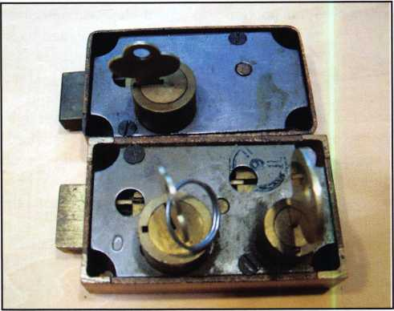

photo.1 - Here are two different same footprint or size one with a single nose and the other having two noses.

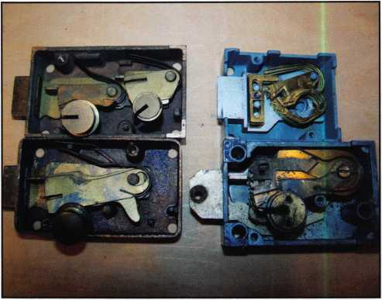

photo.2 - The locks on the left are the two from photo 1 with the covers removed. Both of these locks have fixed levers. The two on the right are both single nose locks the bottom lock has resetable levers. The upper one on the right has a re- setable fence.

Keynotes • December 2007

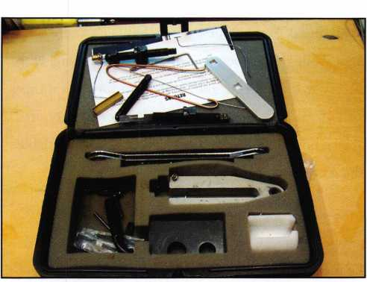

There’s good news and bad news in safe deposit work. The good news is generally there is less than a dozen major manu­facturers in the business with maybe another dozen bit play­ers although they might not want to be called bit players.

The bad news is that some make several variations each and in some cases in an attempt to compete they have redesigned their own lock to accept a guard key from a different manu­facturer. They also have made complete locks to interchange or fit in other openings. Add to the mix a few after-market companies producing both direct copies and this can make opening, and perhaps service more difficult. On the other hand information, tools, new replacement locks, and compa­nies that specialize in providing reconditioned used locks and there has never been an easier time to provide safe deposit locks. A safe deposit identification manual is available from Lockmasters, it shows lots of dimensions. Other books are available from the ALOA store or The National Locksmith.

There are three common methods to open these kinds of locks and few other less used methods. Picking or even im- pressioning pin tumbler cylinders can be a good choice. It can also be used if you are good at picking lever locks. Some locks like the Diebold 175-70 can be picked with specially designed picks and other tools have been designed for decod­ing the levers in specific locks. The next two methods are probably the most common choice and depend on three dif­ferent factors. First, the design of the lock; second, the avail­ability of replacement locks and or repair parts; and third, your preference. The choice is between pulling the nose and drilling and picking. Pulling the nose is a great choice on currently produced relatively inexpensive and available locks. Drilling and picking may be a better choice you need to save the lock. We’ll look at these methods a little later. The less common methods are door pulling that destroys the lock, drilling for hinge screws or cutting the hinge, and if needed you drill out the lock mounting screws.

Once you have the knowledge to work on safe deposit locks what kind of tools do you need to service this specialty? Lets assume you have the basic complement of hand tools, like screwdrivers and small hammers and skip to the specialty

photo.5 - This is the Lockmasters Neutralization Kit. It contains a wide variety of tools used to open and service safe deposit locks. It also has a few home­made tools included in the kit.

photo.4 - This lock has a multi-fence design that is held together with a screw and nut. All the levers are identical and the fence for each lever is set individu­ally. Drilling and picking the top lock is not feasible.

photo.3 - shows a close up of the resetable levers in the lock. In this case the levers are separated with a change key and can be reset to a different key.

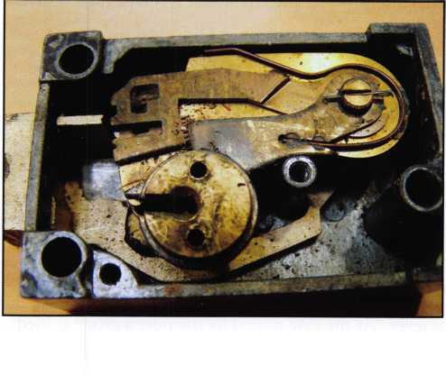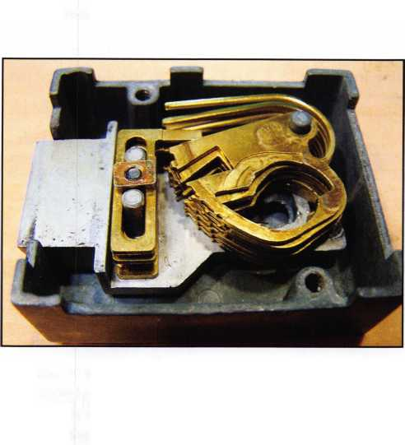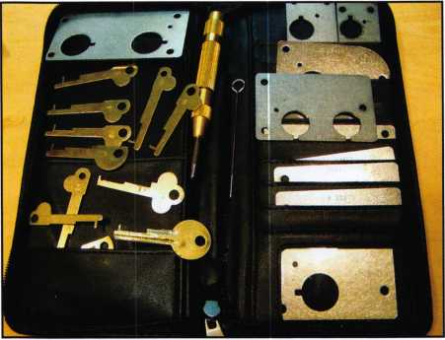

photo.6 - TimeMaster template kit contains a va­riety of templates for various locks.

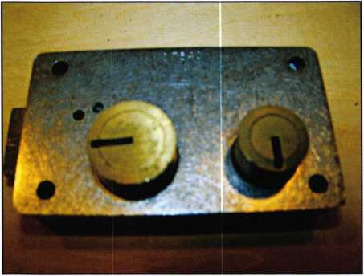

photo.7 - One of the templates on a Diebold lock.

tools. First to open the lock you have some choices. First and perhaps most the common tool is a puller to pull the nose of the lock. Over the years a number of technicians have developed pullers, some better than others but most have gone by the wayside. Quality pullers are available from Lockmasters, Timemasters, MBA, Major Manufactur­ing, HPC, and probably others I have forgotten or not seen. Some are faster operating and others are more versatile, the choice is yours, but if you’re first starting out and money is scarce, stick with the more versatile puller. Once the nose is pulled you need to either buy or create a turning tool. This can be as simple as a bent piece of stiff wire or a profession­ally produced tool. The basic idea is once the nose and plug have been removed the levers will drop below the fence and a tool is used to retract

the bolt. In most cases the guard side is set or turned first, although if it is not available then both sides must be pulled.

The second most common method is to drill and pick the lock. The basic concept is similar to shim picking or shim­ming a pin tumbler cylinder. Start by inserting the guard key and setting that side. A hole is drilled where the fence would enter the gates on the levers. Next a lifting tool which is just a key cut with only the tip cut left is used to lift the lever. As the gate passed by the hole a probe is used to hold it at the location. Next move the next lever into position until they are all held by the probe. Now move your pick key to the bottom or foot of the lock and retract the bolt partially, hold the tension. This should hold all the levers in place as you remove the probe. Once the probe is removed the fence should fully enter the gates and the bolt will retract. How do you decide where to drill? The easiest answer is to use a template. Either make your own or pur­chase a set from TimeMaster. If you don’t have a template remove a lock from an open or un-rented box and measure.

Once you have the lock opened it can be removed from the door and key fitting or repair can begin. How do you fit a key? Disassemble the lock and read the numbers on the levers in some case others require the old trial and error method if no numbers are on the levers. This is where your skills are put to the test. Careful measuring for both depth and space can tax even the best of us. Some locks are very consistent while others seem to have been hand made with each factory worker having a different idea for the appropri­ate depth of cut. To help with this task John Cannon has developed a book of most depths and spaces, it is available from the ALOA bookstore.

Next time we will start looking at specific locks and the ways to open them. Often there are multiple choices and like most jobs it’s nice to have more than one option available.

Keynotes • December 2007

Why Isn’t My Business Making Money?

By Sam Horn



Is your business not making as much money as it could or should?

The hotel bar/restaurant had a problem. No one was com­ing to their happy hours. Why? They were one of dozens of restaurant/bars in the area hosting happy hours. No won­der they weren’t making any money; they were getting lost in the crowd. The question is, how could they stand out from the crowd?

The enterprising manager noticed that one of their loyal patrons tied his dog up outside when he came in for a cold one after work.

Light-bulb moment. Why not offer a special happy hour for professionals who wanted to bring along their poor pooches that had been cooped up all day while their owner was away? They could put out water bowls, hand out dog biscuits and offer a discount on beer so it was a win for everyone.

What to call this? Well, use a POP! technique called Al­phabetizing in which you talk your word through the al­phabet, “Aaapy Hour, Bappy Hour, Cappy Hour, Dappy Hour” . . . and you eventually get to Yappy Hour!

You may be thinking, “Big deal, so it’s a clever name.”

You bet it’s a big deal. The Washington Post wrote an arti­cle about the throngs of people showing up for the restau­rant’s wildly popular (and profitable) Yappy Hour. That article was picked up by a hundred newspapers across the country. As a result, millions of people now know about the Alexandria, VA Holiday Inn’s successful Yappy Hour.

Is your business not making as much money as it could or should?

Chances are you’re one-of-many. One of many restaurants consultants, stores or companies that all look alike. If you’re offering the same services and products as everyone else, how are people supposed to notice you?

Here’s five of the top ten ways to be one-of-a-kind (instead of one-of-many) so you break out instead of blend in and increase your volume of customers and income.

1. Give your business a one-of-a-kind name that gener­ates free media attention. Sure, you can call your busi­ness The Nail Place—or you can call it Texas Chainsaw Manicure. Guess which attracts clients from around the world because they’ve read about it in syndicated columns or seen it featured on TV?
2. Zig where your competitors zag. Enterprise wanted to enter the crowded car rental industry but Hertz, Avis, Budget and Alamo owned the market. Hmmm . . . how

Keynotes • December 2007

to differentiate themselves? What did competitors have in common? They re all situated next to airports. So, Enter­prise located their branches in neighborhoods. What didn’t the other agencies offer? No pick up and drop off service. So, Enterprise offers to drive you to and from your home or hotel. The moral of this story? Don’t do what everyone else is doing; do the opposite. The best way to stand out from your crowd is to lead it, not follow it.

1. If you have fun, your customers will too. Art Buch- wald said, “I learned when I made people laugh, they liked me.” Read your signage, web copy, and marketing material. Does it make you laugh? If not, it’s probably costing you sales. Inject some humor into your communication to in­crease likeability. A local ice cream store has a sign by the cash register that says, “Why do we have square containers? Because we don’t cut corners on the quality of our ice cream.” A shoe store replaced their standard “Sale” ad with “ Shopportunity. 50% off — and that’s just the half of it.” Which ad do you think generated more business?
2. Turn generic into genius. Jay Sorenson saw what every­one else saw - those cardboard insulating sleeves you put around your cup of coffee so you don’t burn your fingers- and turned them into a 15 million dollar a year business. How? By giving a common product an uncommon name - Java Jacket. Sorenson said, “That trademarked name is worth more than our patents - it has such a dominant mar­ket awareness that people who meant to call our competi­tors call us instead.” That’s branding! Say Dunkin Croissants. Best Purchase. Those words sound clunky, don’t they? Now say Dunkin Donuts. Best Buy. Give your business a short, alliterative name that’s easy to pronounce and remember . . . and you’ve just given yourself an atten­tion-getting, money-making brand.

5. Listen to your customers whine. “What?!” you may be asking in disbelief. “Why should I listen to people com­plain?” Because they’re telling you what they have a prob­lem with. If you fix that problem, they’ll flock to you. For example, a Hawaii dive shop got tired of turning away cus­tomers who didn’t have a current scuba certification. Solu­tion? Why not have an air hose from the boat people keep in their mouth, kind of like an elongated snorkel? This way, anyone can swim with the fishes 10-20 feet down without risk (you can resurface in seconds) and without hauling around heavy oxygen tanks. Let’s use a POP! tech­nique to coin a brand new name for this activity. It’s half snorkel - half scuba. It’s SNUBA! Solve a common indus­try problem and give it a clever name and customers will seek you out because you’re the only one offering this first- of-its-kind option.

Best-selling author/branding expert Sam Horn has helped more than 50,000 individuals create one-of-a-kind approaches that dramatically increased their name recognition, visibility and sales. Visit [www.SamHornPOP.com](http://www.SamHornPOP.com) for a free article on the other five ways to get your business noticed and remembered. . . for all the right reasons.

**34**

Keynotes • December 2007

**Classifieds**

MOBILE LOCKSMITH BUSINESS FOR SALE

EMPLOYMENT

LOCKSMITH TECH NEEDED

Need energetic Locksmith Tech with good work­ing skills, computer experience and warehouse skills a plus!!!!! Hours: Mon-Fri, 8am-5pm. Good driving record required. Retirement Plan, Health Insurance, Salary Negotiable. Estab­lished, well known company in business since 1964. Sword Company, 6525 South Broad­way, Tyler, Texas 75703 Ph: 903-561-1961. Send resume to Fax 903-561-4932 or email: [mike@swordco.com](mailto:mike@swordco.com)

SALES PERSON NEEDED

Nevada Lock Supply, a wholesale lock supply company located in beautiful Las Vegas, seeks a front counter sales person. Must have 2 years of lock experience and good communication skills. Competitive salary and benefits package. Contact John at [jmiers@nevadalock.com](mailto:jmiers@nevadalock.com)

LOCKSMITH - STORE MANAGER WANTED

New Locksmith store opening October in Aven­tura, Florida. We are looking for an experi­enced locksmith to run the store. Great opportunity for the right person. Qualifications: Experienced Locksmith and knowledgeable about hardware. Retail store experience. Can do estimates and sell jobs. Interact and commu­nicate well with clients. Bilingual - English/ Spanish. Self-starter and problem solver. Lock­smith's License, Driver's License. Salary Open. Email: [aviva@soslockmith.com](mailto:aviva@soslockmith.com)

LOCKSMITH WANTED-NEW YORK CITY

Experienced Locksmith and knowledgeable about hardware. Can do estimates and sell jobs. Interact and communicate well with clients. Locksmith's Li­cense, Driver's License. Manhattan Location. Salary Open, [aviva@soslockmith.com](mailto:aviva@soslockmith.com)

LOCKSMITH OR APPRENTICE-BOZEMAN, MONTANA, THE BEST PLACE Bozeman Safe & Lock is a provider of security hardware, systems, and services in the south central region of Montana. We are the region's market leader in developing professional and effective security soluctions to diverse commer­cial, residential, and safe problems. Consider being part of our team! Visit our website at [www.bozemansafandlock.com](http://www.bozemansafandlock.com). Appropriate certification(s) a plus. Competitive salary, bene­

fit package. Call Rich at 406-570-51 34 or email: [rich@bozemansafeandlock.com](mailto:rich@bozemansafeandlock.com).

EXPERIENCED LOCKSMITH NEEDED - SIGN-ON BONUS RELOCATION AS­SISTANCE

60 year old Austin, Texas company with 5 loca­tions and 29 service vehicles is seeking experi­enced technicans as well as shop management candidate. We offer competitive wages based on experience, commissions, overtime, medical benefits, 401k, cafeteria plan, paid vacations, sick leave and holidays. We supply the vehicle and tools, you supply the talent. Our customers are residential, commericial and industrial and institutional. We also do access control, CCTV, and alarms. Opportunity for education, growth and advancement is tremendous. The right can­didates will be given a 'sign on" bonus. Reloca­tion assistance is also available. Must be able to meet requirements of State of Texas for licens­ing. If interested, send resume to: [jimh@cothrons.net](mailto:jimh@cothrons.net) or fax to 512-459-2828.

SALES REPRESENTATIVE WANTED JMA, USA, a leading European key manufac­turer is looking for sales representatatives for various US territories. The sales representative will be responsible for managing existing ac­counts in each territory and to open new ac­counts. Please send resume to Mike Ripoll, email address: [mripoll@jmausa.com](mailto:mripoll@jmausa.com).

EXPERIENCED LOCKSMITH WANTED Established company, Bend Oregon requires full time locksmith. Experi­enced in commerical, residential and auto. Must be motivated team player. Paid vactiona, hoi- days and benefits. Email [bedlocksafe@bend- broadband.com](mailto:bedlocksafe@bend-broadband.com) or call Mary at 541-948-6073.

LOCKSMITH WANTED High volume mobile/storefront shop in San Dimas, CA. We are seeking a technician for a full time position servicing Residential, Commeri­cal, and Automotive. We are willing to train a self motivated person with some experience. Good driving record requiried. Retirement Plan and Health Insurance available. Call Chris at 909-599-3178 or email [chris@sanderslock.com](mailto:chris@sanderslock.com)

WANTED TO BUY/SELL

In Kansas City area. Well established with loyal customers. Strong with banks and schools. One person business with plenty of room for expan­sion opportunity. Great reputation! Owner retir­ing. Call Bob Badgley 1-800-966-2005

FOR SALE

Abloy disklock key cutting machine model 6200 with original instructions and 25 disc key blanks. No more than 100 keys have been cut on this machine which his in 'like new' condi­tion. Original price was $1775.00. Selling price $550.00 including shipping anywhere in the U.S. Richard Grudens, Edison Locksmiths, 425 North Country Road, St. James, New York, 1 1780, or [rgrudensl@aol.com](mailto:rgrudensl@aol.com) Fax 631-0139.

TOOL WANTED

Best 1C Tool Wanted. Best stamping plate wanted. Single core block, 5 core plate or larger plate. Used is fine. Please call Randy Main at 1-800-352-1773

FOR SALE

Van & Equipment for sale. 2005 Chevy Express 6 cyl. Auto air, cab driver with door, shelf unit & pinning table. 2 HPC key machines (Power Speedex 91 80MC & 1200CMBX with Codes­ource Plus, Mastering, extra cutters & Medeco Freedom jaw). Large asst, of keys with spill proof hooks, Premium auto lockout kit, Best Damn Car Opening Manual, Herty Gerty & Medeco Freedom Pinning kit. Must retire to care for wife. Call or email for more information or pricing. Woodbury, TN (45 mi SE of Nashville) Phone 615-563-9068 FAX 615-563- 9206 or email to [abreau@dtccom.net](mailto:abreau@dtccom.net)

ALARM BUSINESS FOR SALE Central Idaho Alarm business for sale. Only se­curity company within a hundred mile radius in a super fast growing resort area. Four hundred + current monitored

customers. Security systems, commercial fire systems, structured wiring, CCTV, home theater and audio and access control. Very profitable with a great reputation and large customer base. Email: [aviator@citlink.net](mailto:aviator@citlink.net) for more info.

Classified Advertising Policy

Classified advertising space is provided free of charge to ALOA members and for a fee of $2.00 per word, $40.00 minimum for non members. Classified ads may be used to advertise used mer­chandise and overstocked items for sale, "wanted to buy" items, business opportunities, employment opportunities/positions wanted and the like. Members or non members wishing to advertise services or new merchandise for sale may purchase a "Commercial Classified Ad" for a fee of $4.00 per word with a minimum of $ 100.00. Each ad will run for two issues. For blind boxes there is a $10.00 charge for members and non members. All ads must be submitted in writing to the Advertising Sales Department via fax at 817-645-7599 or through an email to [adsales@aloa.org](mailto:adsales@aloa.org) by the fifteenth of the month two months prior to issue date. ALOA reserves the right to refuse any classified advertisement that it deems inappropriate according to the stated purpose of the classified ad­vertising section.

Keynotes • December 2007



Distributor

**1 st In Hardware, Inc.**

Phone: 410-646-9900 Fax: 410-646-0045 www. 1 stinhardware.com

**ADEL Fingerprint Technology, LLC**

Phone: 909-595-1222 Fax: 909-595-1667

**Accredited Lock Supply Co.**

Phone: 800-652-2835 Fax: 201-865-2435 [www.acclock.com](http://www.acclock.com)

**American Auto Lock.Com**

Phone: 717-392-6333 Fax: 717-581-8353 [www.americanautolock.co](http://www.americanautolock.co) m

**Boyle & Chase Inc.**

Phone: 800-325-2530 Fax: 800-205-3500 [www.boyleandchase.com](http://www.boyleandchase.com)

**Clark Security Products**

Phone: 858-974-6740 Fax: 858-974-6720 [www.clarksecurity.com](http://www.clarksecurity.com)

**Cook's Building Specialties**

Phone: 505-883-5701 Fax: 505-883-5704

**Dire's Lock & Key Company**

Phone: 303-294-0176 Fax: 303-294-0198

**Direct Security Supply, Inc.**

Phone: 800-252-5757 Fax: 800-452-8600

**Doyle Security Products**

Phone: 800-333-6953 Fax: 612-521-0166 [www.doylesecurity.com](http://www.doylesecurity.com)

**Dugmore and Duncan, Inc.**

Phone: 888-384-6673 Fax: 888-329-3846

**E. L. Reinhardt Co., Inc.**

Phone: 800-328-1311 Fax: 651-481-0166 [www.elreinhardt.com](http://www.elreinhardt.com)

**Foley-Belsaw**

**Company**

Phone: 800-821-3452 Fax: 816-483-5010 [www.foley-belsaw.com](http://www.foley-belsaw.com)

**Fried Brothers Inc.**

Phone: 800-523-2924 Fax: 215-592-1255 [www.fbisecurity.com](http://www.fbisecurity.com)

**H.L. Flake Co.**

Phone: 800-231-4105 Fax: 713-926-3399 [www.hlflake.com](http://www.hlflake.com)

**Hardware Agencies, Ltd.**

Phone: 416-462-1921 Fax: 416-462-1922 [www.hardwareagencies.com](http://www.hardwareagencies.com)

**IDN Incorporated**

Phone: 817-421-5470 Fax: 817-421-5468 [www.idn-inc.com](http://www.idn-inc.com)

**Instant Hardware Delivery, Inc**

Phone: 800-355-1 107 Fax: 800-663-8518

**Intermountain Lock & Security**

Phone: 800-453-5386 Fax: 801-485-7205 [www.imlss.com](http://www.imlss.com)

**Jovan Distributors, Inc**

Phone: 416-288-6306 Fax: 416-752-8371 [www.jovanlock.com](http://www.jovanlock.com)

**L V Sales Inc**

Phone: 323-661-4746 Fax: 323-661-1314 [www.lvsales.com](http://www.lvsales.com)

**Lockmasters, Inc.**

Phone: 859-885-6041 Fax: 859-885-7093 [www.lockmasters.com](http://www.lockmasters.com)

**Locks Company**

Phone: 800-288-0801 Fax: 305-949-3619

**Locksmith Ledger International**

Phone: 847-454-2700 Fax: 847-454-2759 [www.lledger.com](http://www.lledger.com)

**McDonald Dash Locksmith Supply Inc.**

Phone: 800-238-7541 Fax: 901-366-0005 [www.mcdonalddash.com](http://www.mcdonalddash.com)

**NLS Lock Supply Dba Nevada Lock Supply**

Phone: 702-737-0500 Fax: 702-737-7134

**Omaha Wholesale Hardware**

Phone: 800-238-4566 Fax: 402-444-1664 [www.omahawh.com](http://www.omahawh.com)

**Phoenix Safe International LLC**

Phone: 765-483-0954 Fax: 765-483-0962 [www.phoenixsafeusa.com](http://www.phoenixsafeusa.com)

**Positive Identity Solutions**

Phone: 704-663-1 175 Fax: 704-660-1301 [www.pids-usa.com](http://www.pids-usa.com)

**Red Hawk Industries**

Phone: 800-843-4810

**Security Distributors Inc**

Phone: 800-333-6953 Fax: 612-524-0166

**Southern Lock and Supply Co.**

Phone: 727-541-5536 Fax: 727-544-8278 [www.southernlock.com](http://www.southernlock.com)

**Stone & Berg Wholesale**

Phone: 800-225-7405 Fax: 800-535-5625

**The Locksmith Store Inc.**

Phone: 847-364-5111 Fax: 847-364-5125 [www.locksmithstore.com](http://www.locksmithstore.com)

**The Ultimate Distribution Company**

Phone: 254-681-2277 Fax: 254-953-4933 [www.ultimatelocksales.com](http://www.ultimatelocksales.com)

**Timemaster Inc.**

Phone: 859-259-1878 Fax: 859-255-0298 [www.time-master.com](http://www.time-master.com)

**Top Notch Distributors, Inc.**

Phone: 570-753-5625 Fax: 570-253-7178 [www.topnotch.bz](http://www.topnotch.bz)

**Turn 10 Wholesale**

Phone: 800-848-9790 Fax: 800-391-4553

**U.S. Lock Corp.**

Phone: 800-925-5000 Fax: 800-338-5625 [www.uslock.com](http://www.uslock.com)

Manufacturer

**A & B Safe Corporation**

Phone: 800-253-1267 Fax: 856-863-1208 [www.a-bsafecorp.com](http://www.a-bsafecorp.com)

**ABUS KG**

Phone: 492-335-634151 Fax: 233-563-4130 [www.abus.com](http://www.abus.com)

**ABUS Lock Company**

Phone: 800-352-2287 Fax: 602-516-9934 [www.abus.com](http://www.abus.com)

**Access Security Products Ltd.**

Phone: 905-337-7874 Fax: 905-337-7873 [www.access-safe.com](http://www.access-safe.com)

**Accu-Key Lock &**

**Safe Inc**

Phone: 937-294-4241 Fax: 937-294-6565

**Adams Rite Mfg Company**

Phone: 800-872-3267 Fax: 800-232-7329 [www.adamsrite.com](http://www.adamsrite.com)

**Adrian Steel Company**

Phone: 800-677-2726 Fax: 517-265-5834 [www.adriansteel.com](http://www.adriansteel.com)

**Advanced Diagnostics USA Inc**

Phone: 650-876-2020 Fax: 650-876-2022 [www.autokeys.com](http://www.autokeys.com)

**Alarm Controls Corporation**

Phone: 631-586-4220 Fax: 631-586-6500 [www.alarmcontrols.com](http://www.alarmcontrols.com)

**All Five Tool Company, Inc.**

Phone: 860-583-1691 Fax: 860-583-4516 [www.all5tool.com](http://www.all5tool.com)

**American Security Products**

Phone: 909-685- 9680x2013 Fax: 909-685-9685 [www.amsecusa.com](http://www.amsecusa.com)

**Bianchi USA, Inc.**

Phone: 800-891-2118 Fax: 216-803-0202 [www.bianchi](http://www.bianchi) 1770usa.com

**Buddy Products**

Phone: 312-733-6400 Fax: 312-733-8356 [www.buddyproducts.com](http://www.buddyproducts.com)

**CCL Security Products**

Phone: 800-733-8588 Fax: 847-537-1800 [www.cclsecurity.com](http://www.cclsecurity.com)

**36**

Keynotes • December 2007

associate

members

**CompX Security Products**

Phone: 864-297-6655 Fax: 864-297-9987 [www.compx.com](http://www.compx.com)

**D&D Technologies (USA), Inc.**

Phone: 714-677- 1300x292 Fax: 714-677-1299 [www.ddtechglobal.com](http://www.ddtechglobal.com)

**DETEX Corp.**

Phone: 800-729-3839 Fax: 830-620-6711 [www.detex.com](http://www.detex.com)

**Don-Jo**

**Manufacturing, Inc.**

Phone: 978-422-3377 Fax: 978-422-3467 [www.don-jo.com](http://www.don-jo.com)

**Door Controls International**

Phone: 800-742-3634 Fax: 800-742-0410 [www.doorcontrols.com](http://www.doorcontrols.com)

**Doorking Inc.**

Phone: 800-826-7493 Fax: 310-641-1586 [www.doorking.com](http://www.doorking.com)

**Dorma Architectual Hardware**

Phone: 717-336-3881 Fax: 717-336-2106 [www.dorma-usa.com](http://www.dorma-usa.com)

**DynaLock Corp**

Phone: 860-582-4761 Fax: 860-585-0338 [www.dynalock.com](http://www.dynalock.com)

**FireKing Security Group**

Phone: 800-457-2424 Fax: 800-896-6606 [www.fireking.com](http://www.fireking.com)

**Framon Manufacturing Company Inc.**

Phone: 989-354-5623 Fax: 989-354-4238 [www.framon.com](http://www.framon.com)

**G-U Hardware Inc.**

Phone: 757-877-9020 Fax: 757-877-9720 [www.g-u.com](http://www.g-u.com)

**HPC, Inc.**

Phone: 847-671-6280 Fax: 847-671-6343 [www.hpcworld.com](http://www.hpcworld.com)

**HY-KO Products Co.**

Phone: 330-467-7446 Fax: 330-467-7442

**Hammerhead Industries, Inc.**

Phone: 805-658-9922 Fax: 805-658-8833 [www.gearkeeper.com](http://www.gearkeeper.com)

**Ingersoll Rand**

**Security**

**Technologies**

Phone: 317-810-3801 Fax: 317-805-5779 [www.schlagelock.com](http://www.schlagelock.com)

**Jackson Corporation**

Phone: 323-269-81 1 1 Fax: 800-888-6855 [www.jacksonexit.com](http://www.jacksonexit.com)

**Jet Hardware Mfg., Co.**

Phone: 718-257-9600 Fax: 718-257-0973 [www.jetkeys.com](http://www.jetkeys.com)

**KABA ILCO Corp.**

Phone: 252-446-3321 Fax: 252-446-4702 [www.kaba-ilco.com](http://www.kaba-ilco.com)

**KEY-BAK/West Coast Chain Mfg.**

Phone: 909-923-7800 Fax: 909-923-0024 [www.keybak.com](http://www.keybak.com)

**Kenstan Lock Company**

Phone: 516-576- 9090x315 Fax: 516-576-0100 [www.kenstan.com](http://www.kenstan.com)

**Keri Systems Inc.**

Phone: 408-435-8400 Fax: 408-435-7163 [www.kerisys.com](http://www.kerisys.com)

**Kustom Key Inc.**

Phone: 800-537-5397 Fax: 800-235-4728 [www.kustomkey.com](http://www.kustomkey.com)

**LAB Security**

Phone: 800-243-8242 Fax: 860-583-7838 [www.labpins.com](http://www.labpins.com)

**Lucky Line Products, Inc.**

Phone: 858-549-6699 Fax: 858-549-0949 [www.luckyline.com](http://www.luckyline.com)

**M.A.G.**

**Manufacturing**

Phone: 714-891-5100 Fax: 714-892-6845

[www.magmanufacturing.com](http://www.magmanufacturing.com)

**MPT Industries, Inc.**

Phone: 973-989-9220 Fax: 973-989-9234 [www.mptindustries.com](http://www.mptindustries.com)

**MUL-T-LOCK USA, Inc.**

Phone: 800-562-351 1 Fax: 973-778-4007 [www.mul-t-lockusa.com](http://www.mul-t-lockusa.com)

**Maxcess Card Systems Inc**

Phone: 800-713-4823 Fax: 650-692-9410 [www.maxcess-card.com](http://www.maxcess-card.com)

**Medeco Security Locks**

Phone: 540-380-5000 Fax: 540-380-5010 [www.medeco.com](http://www.medeco.com)

**Mil-Comm Products Co Inc**

Phone: 201-935-8561 Fax: 201-935-6059

**Pacific Lock Company**

Phone: 888-562-5565 Fax: 818-678-6600 [www.paclock.com](http://www.paclock.com)

**Protex Safe Co., LLC**

Phone: 818-610-8030 Fax: 818-610-8004 [www.protexsafe.com](http://www.protexsafe.com)

**RA-Lock Company**

Phone: 800-777-6310 Fax: 972-775-6316 [www.ralock.com](http://www.ralock.com)

**ROFU International Corp.**

Phone: 800-255-7638 Fax: 888-840-7272 [www.rofu.com](http://www.rofu.com)

**Rutherford Controls Int'l Co.**

Phone: 519-621-7651 Fax: 519-621-7939 [www.rutherfordcontrols.c](http://www.rutherfordcontrols.c) om

**Sargent &**

**Greenleaf, Inc.**

Phone: 859-885-941 1 Fax: 859-885-3063 [www.sargentandgreen- leaf.com](http://www.sargentandgreen-leaf.com)

**Sargent**

**Manufacturing Co.**

Phone: 800-727-5477 Fax: 888-863-5054 [www.sargentlock.com](http://www.sargentlock.com)

**Schwab Corp.**

Phone: 765-447-9470 Fax: 765-447-8278 [www.schwabcorp.com](http://www.schwabcorp.com)

**Securifort Inc**

Phone: 819-359-2226 Fax: 819-359-2218 [www.securifort.com](http://www.securifort.com)

**Securitron Magnalock Corp.**

Phone: 775-355-5625 Fax: 775-355-5636 [www.securitron.com](http://www.securitron.com)

**Security Door Controls**

Phone: 805-494-0622 Fax: 805-494-8861 [www.sdcsecurity.com](http://www.sdcsecurity.com)

**Security Solutions**

Phone: 405-376-1600 Fax: 405-376-6870 [www.securitysolutions- usa.com](http://www.securitysolutions-usa.com)

**Select Engineered Systems**

Phone: 305-823-5410 Fax: 305-823-5215 [www.selectses.com](http://www.selectses.com)

**Townsteel, Inc.**

Phone: 626-858-5080 Fax: 626-858-3393 [www.townsteel.com](http://www.townsteel.com)

**Trine Access Technology**

Phone: 718-829-2332 Fax: 718-829-6405 [www.trineonline.com](http://www.trineonline.com)

**Videx Inc.**

Phone: 541-758-0521 Fax: 541-752-5285 [www.videx.com](http://www.videx.com)

**WIKK Industries Inc.**

Phone: 414-421-9490 Fax: 414-421-3158 [www.wikk.com](http://www.wikk.com)

**WMW Innovation Company**

Phone: 888-474-2341 www. su re-str i ke.com

Service

Organization

**Allstate Insurance Company**

Phone: 847-551-2181 Fax: 847-551-2732 [www.allstate.com](http://www.allstate.com)

**HRH Insurance**

Phone: 817-462-3630 Fax: 817-462-3680 [www.hrh.com](http://www.hrh.com)

**Red Hawk**

Phone: 901-332-291 1 Fax: 901-332-2878 [www.webstersinc.com](http://www.webstersinc.com)

**The Mechanic Group, Inc.**

Phone: 845-735-0700 Fax: 845-735-8383

[www.mechanicgroup.com](http://www.mechanicgroup.com)

Keynotes • December 2007

**3**

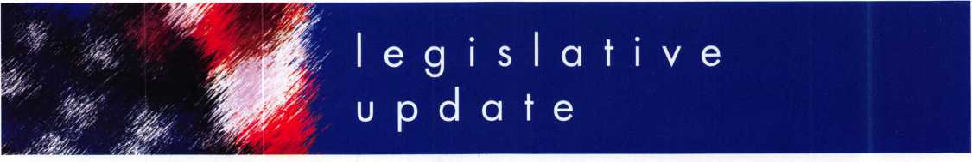

***KEYNOTES*** - ***DECEMBER 2007***

**ALOA MEMBERS ALWAYS HAVE GREAT IDEAS.**

At the Convention in Charlotte this year, Legislative Action Network (LAN) Council member Kenneth A. Griffin, CML, CPS offered this piece of advice, "If you add the LAN Council membership of $100 to the ALOA renewal notices, I bet you get more people to sign up." And right he was! Over 30 members have signed up or re-joined the LAN Council so far:

John B. Arnold, CML

Joseph E. Bednarski

Michael Bronzell

James J. Cawby, CML, CPS

Chris W. Cyree, CPL

William Dischler

R. Terry Earll, CML

Laura C. Easterling

Lance A. Edwards

Gary W. Ford, CRL

Guy Gabai

Jason Gage

Lowry R. Gentry

Kenneth A. Griffin, CML, CPS

Edward S. Haney

William F. Hoffmann

John K. Hubei, CML

George Huntoon

Paul M. Justen

Brian Leffingwell

Karen Maples

Art Misiewicz, CRL

Kenneth Morgan

Manuel L. Ribeiro

Tom Rip

David Satchi

John W. Soderland, CML, CMST

Hadi Wahba

Danny L. Whitaker, CRL

Edward R. Woods, CML, CPS

Roy Yetter, RL

Glenn Younger

What does it mean to be on the LAN Council? LAN Council member receive a quarterly Legislative Action Network Update alerting them to important legislation in their state and around the country (same as LAN member, a comprehensive guide to lobbying at the state capital, so they can be the "voice of ALOA" to legislators, a lapel pin designating them as a special ALOA LAN Council member, recognition in Keynotes magazine, invitation to exclusive functions at the an­nual ALOA convention for LAN Council members and a complimentary Legislative Convention merchandise (it was business card holders this year with the ALOA logo).

It's simple to join the LAN Council:

* Log into the ALOA Store at http:/ / [www.aloa.org/store](http://www.aloa.org/store)
* Click on Search and type in "Council"
* From there you can join at four different donor levels
* Add this to your basket and checkout!

Note: if this is the first time you have used the ALOA Store since December 2004, you will need to set up a username and pass­word.



Keynotes • December 2007

**ALOA Legislative Update as of 11/24/2007 Ken­tucky — 2008 Prefiled HB 41**

TITLE: AN ACT relating to alarm systems.

ABSTRACT: Creates an Alarm System Contractor Licensing. STATUS: Prefiled and sent to Interim Joint Committee on Li­censing and Occupations NOTES: Definition of alarm system is so broad that it in­cludes access control and most locking systems.

**Massachusetts 2008 Car­ryover Bills SB 1989**

SPONSOR: Richard R. Tisei TITLE: An Act Relative to Mod­ernizing the Requirements for Electrical Trade Practice ABSTRACT: Licensing of electri­cians

STATUS: In Committee.

NOTES: This bill provides for the licensing of electricians over "Security Systems" which the definition includes access control.

**New Jersey 2007 No carryover (it will die if not passed by 12/31/2007)**

**AB 2520**

SPONSOR: Johnson,

Gordon M.

TITLE: Concerning electronic security systems.

ABSTRACT: Exempts certain businesses from licensing re­quirements for those engaged in burglar alarm, fire alarm and electronic security system installations.

STATUS: Introduced, Referred to Assembly Regulated Profes­sions and Independent Authori­ties Committee NOTES: This bill changes the definition of "electronic secu­rity system" contained in the law so that it does not include access control systems, closed circuit television systems or in­tercom systems.

**AB 4041**

SPONSOR: Chatzidakis, Larry TITLE: Concerning certain lock picking tools.

ABSTRACT: Establishes penal­ties for manufacture, purchase or possession of "bmp" keys. Status: Introduced and referred to Assembly Law and Public Safety Committee NOTES: Establishes penalties for manufacture, purchase or possession of bump keys.

**Ohio 2008 Carryover Bills HB 41**

SPONSOR: Uecker

Title: Security systems-licens-

ing/regulation

ABSTRACT: To require the li­censure of persons operating security or life-safety systems companies orcompanies pro­viding locksmith services and of individuals performing spec­ified types of security or life- safety systems work or locksmith services and to es­tablish the Security or Life- Safety Systems Advisory Board in the Office of the State Fire Marshal.

STATUS: Passed House and as­signed to Senate ICL Commit­tee

NOTES: This bill is based on

the IASIR Model law that

ALOA and the Burglar Alarm

industry drafted. See

http:/ / aloa.org/pdf/model Jaw.

pdf

**Pennsylvania 2008 Car­ryover Bills HB 727**

SPONSOR: Raymond TITLE: An Act providing for duplicate vehicle keys; and prescribing a penalty. ABSTRACT: An Act provid­ing for duplicate vehicle keys; and prescribing a penalty. STATUS: Introduced and re­ferred to Transportation Com­mittee.

NOTES: While ALOA supports Positive ID legislation, this is very cumbersome.

Keynotes • December 2007

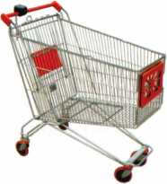

keynotes

Buyer

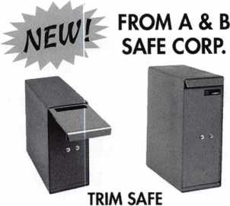

AB-2T AB-2TT

A & B SAFE CORPORATION

114 S. Deisea Drive, Suite 3  
Glassboro, NJ 08028-6237  
856-863-1186 Fax 856-863-1208

IN-STOCK...MORE SAFES

***FREE Freight Program***

*(30 States)*

AMSEC RreKing

Qatdall **hayman**

MEILINK yiCTOR.

**TURPI** to

**WHOLESALE SERVICE**

800-848-9790

N

You need it When?

**How about now!? :-)**



Another Special  
Value-added Benefit to your

ALOA Membership!

Click here

yL

[www.clearstar.com](http://www.clearstar.com) / ALOA

COUCOOCMt

-oooatiu**

kf.y * lociAk.

4525 Hampton Pkoil. (314)752-33(1

CLAIM CHECK

YOUR FIRM NAME I

123 Main

YOUR TOWN, STATE Af

RKon* 123-456?

0004115

**Professional Business Products**

**Invoices**

**Checks**

**Business**

**Cards**

**Tags**

**Key Fobs**

**Magnets**

**Labels**

*Call for a free  
brochure and samples*

**1-800-355-6322**

[www.pbp2000.com](http://www.pbp2000.com)

003634 REPAIR TAG

Keynotes • December 2007

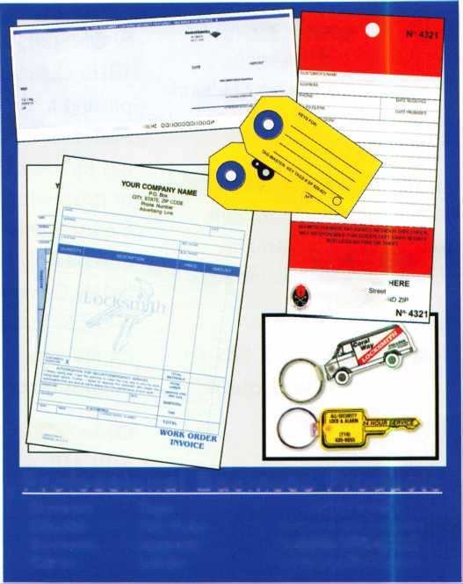

**Single Door Access Control**

f

p

f

With Built-in Card Reader

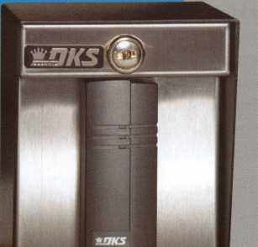

STAND ALONE

SYSTEMS

**DoorKing's model 1520 is a full feature economical single door access controller. The 1520 can be ordered with a built-in proximity card reader or as a controller only allowing you to add your own 26-bit wiegand device. The 1520 is ideal for single door access control in a variety of applications and provides outstanding features.**

* Up to 1000 card codes
* 3600 event transaction buffer
* Timed anti-pass back
* Four time zones
* Print menu
* Real time print mode
* Built-in programming keypad

Call or visit our web site for more information!

Designing and Manufacturing a full line of product since 1948

Gate Operators

**Telephone Entry**

**Parking Control**

**Member: AFA, DASMA, IDA, NOMMA, SIA, SSA**

120 Glasgow Avenue, Inglewood, CA 90301 U.S.A. T: 310-645-0023 1-800-826-7493 F: 310-641-1586 E-mail: [info@doorking.com](mailto:info@doorking.com) [www.doorking.com](http://www.doorking.com)



ACCESS CONTROL SOLUTIONS

for over fifty years

ti—i

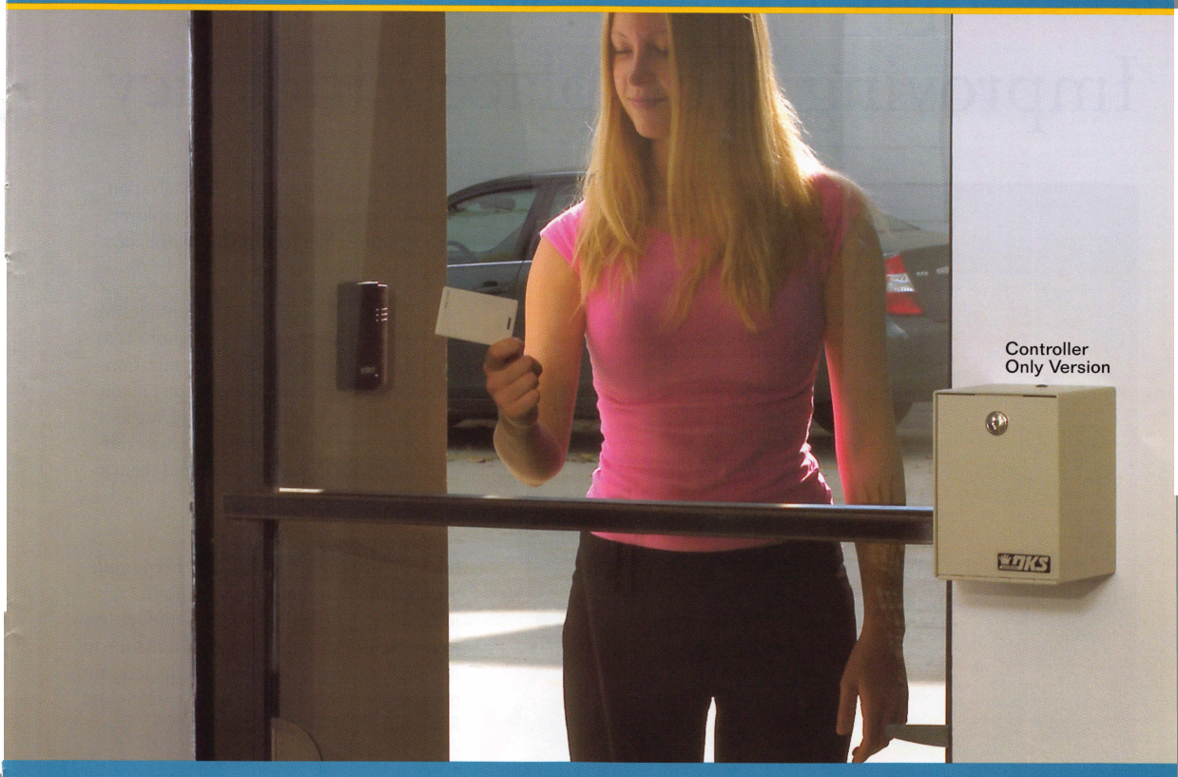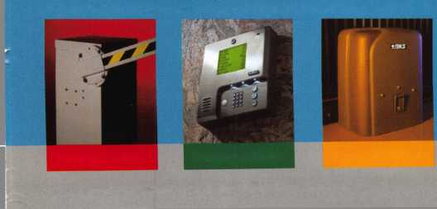

A Simple Method to Improving Workplace Efficiency



Seventy percent of employees are visual learners. How will this affect your company's ability to compete in today's mar­ketplace? For executives, one of the most important business skills they can possess is the talent to communicate effectively with employees.

"To reduce frustration among employees and avoid saying comments such as, "That is not what I said (meant)," employ­ers should visually demonstrate the expectations and instruc­tions of the task," says Steve Jones, chief operating officer and executive vice president, Universal Protection Service.

There are three simple ways to increase the use of visual com­munication in your office environment. By implementing the actions listed below, instructions can be clearly communicated the first time. "Not only will this improve overall productivity

of both the employee and the organization,  
but visual communication helps employees  
become more confident in their work" says  
Jones.

* Combine verbal and visual communication.  
  The best method of giving instructions is to  
  combine verbal and visual communication  
  when delegating a task. For example, if you  
  need to send an employee to an off site loca-  
  tion to pick up office supplies, verbally pro-  
  vide them with directions and hand them a  
  map as a visual guide.
* Demonstrate.

If a new software application has been imple-  
mented, show the employee how to use the  
program, rather than telling the employee how  
to use the program. It may take more time to  
demonstrate, but it saves time in the long-run  
because work will not have to be re-done and  
fewer questions will be asked.

* Solicit feedback.

Although you may think you are clearly com-  
municating an assignment, you  
never know what the employee may have

heard. To prevent miscommunication, ask the employee  
to repeat the instructions and what is expected of them.  
Then, follow up with an email that outlines, in detail, the  
task and the instructions. This reviews what was commu-  
nicated verbally and ensures that both the employer and  
employee are on the same page.

About Universal Protection Service

Founded in 1965, Universal Protection Service combines an innovative mix of tradi­tion with cutting edge systems and technology to keep pace with the ever-evolving needs of today's business environments. Headquartered in Santa Ana, Calif, with of­fices located throughout Arizona, California, Colorado and Washington each employ hands-on and highly experienced management teams, making Universal uniquely po­sitioned to deliver the finest quality security professionals, fire and life safety services, and electronic security solutions that the industry has to offer.

*also available:*

Black Pewter Bright Nickel Brass Plated Sunshine Yellow

Construction Orange Hot Pink Lime Green Cobalt Blue Fire Engine Red

Know when your bag has been searched by a TSA agent, or violated by an unknown person.

SearchAlert Security Window indicates:

• Red Window: Luggage has been searched. O Green Window: Lock Not Opened.

Protected by U.S. Patents 6,877,345 and 7,007,521. The Design of the Lock is a Registered Trademark* of The Eastern Company.



**Security Products** A Division of The Eastern Company **A Proud Union Company. (S.E.I.U.)** 301 West Hintz Road | Wheeling, IL 60090 | Telephone: 800.733.8588 | Fax: 847.537.1881 **[www.cclsecurity.com](http://www.cclsecurity.com)**

**TRAVEL SENTRY**

**APPROVED**

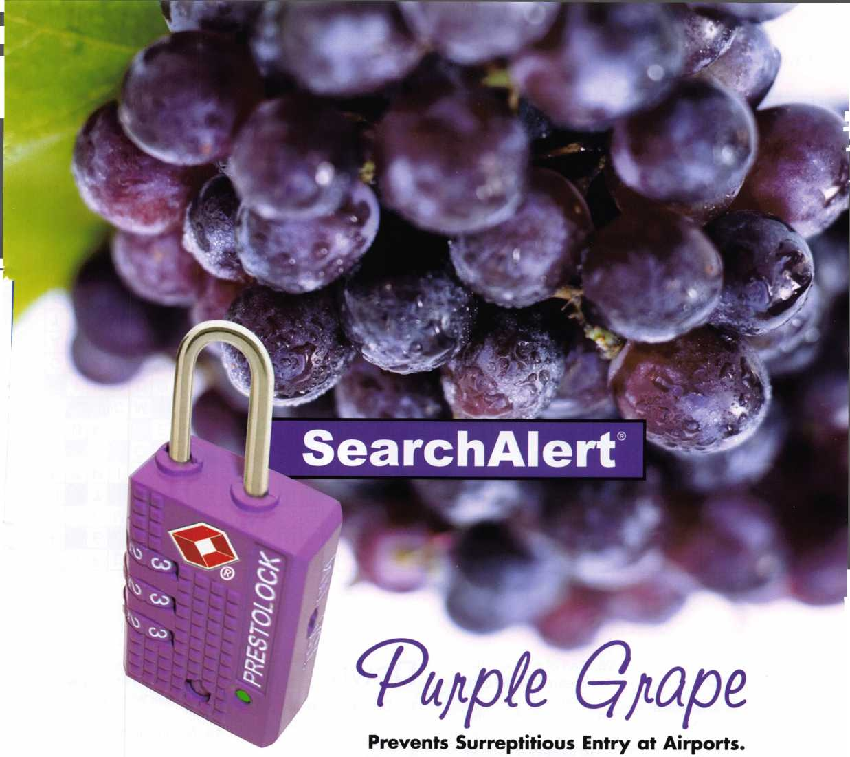

Crossword by Myles Mellor

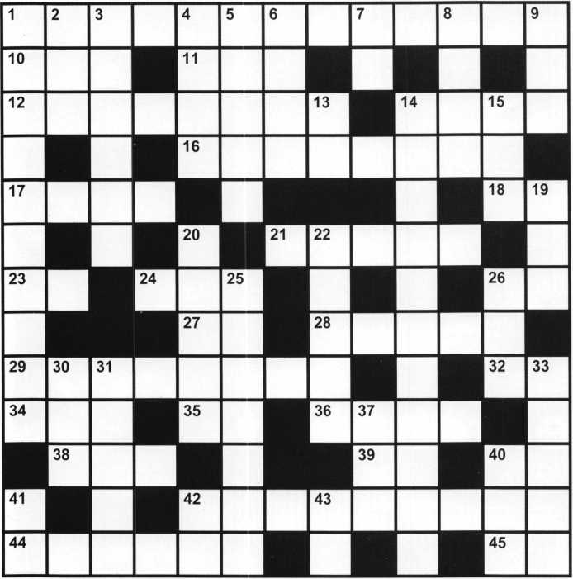

uojinios jequi9A0N



Across

1. Educational qualifica­tion that ALOA provides its members
2. St.'s other name
3. Danger light color
4. Position of the hasp as­sembly with the hole to receive the padlock

14. Halt work

1. Auto diagnostic device used to read fault codes (2 words)
2. Unusual
3. Carry out

21. Push ?

1. Temperature control
2. Help request
3. Provided that
4. Mckinley, for one
5. Part of a bit key be­tween the bow and the stop
6. Hole drilled into the edge of the door where a lockset is to be in­stalled (2 words)

32. Economics, (abbr.)

1. Jerry ?
2. Operation, for short
3. Get confused
4. Emergency master key
5. Approve
6. Promissory note, for short

42. Worked with

1. Cover typically used on the hinge side of many touch bar exit devices (2 words)
2. Start!

Down

1. Device which interprets access coding (2 words)
2. Just before
3. Distance from a door face to the tip end of the lever
4. Part of a video camera
5. Projection on a lock bolt which prevents move­ment of the bolt unless it can enter gates of properly aligned tum­blers
6. Plan
7. Location indicator
8. Very interested in
9. Take a little sleep
10. Nurse, abbr.
11. Data used by software to prevent or deny ac­cess (2 words)
12. Out of date
13. Not functioning cur­rently
14. Combination, for short
15. Type of key cut
16. Temporary, of a solution
17. Pres.
18. Fade away
19. Great grandmaster keyed (abbr.)

33. Good locksmiths are people (2 words)

1. Long time
2. Place to hang your hat
3. Augusta's state
4. Steelers locale
5. Trademark, abbr.

KW1+

ABC KEY  
USA

5S5-1212

EASTER LOCK & KEY V 325-3535 j

USDVA

ILLINOIS

A-1 KEY & LOCK  
24HR SERVICE  
312-555-1234

DUPLICATION

PROHIBITED

**Smart Clone**

**For All Cloneable Keys... Including Ford, Infiniti & Toyota**

**Professional Products for Professional Locksmiths**

**Smart Clone Key Blanks**

**Largest Selection of Groovy Keys Anywhere**

**Displays and Key Assortments**

**Precision Key Machines and Cutters**

**250 Bin Packs**

**View Our Complete Line of Professional Locksmith Hardware at**

**[www.jetkeys.com](http://www.jetkeys.com)**

**Jet**

**Exclusives**

**Uni Bow Neuter Bow Personal Line**

**JET HARDWARE MANUFACTURING CORP**

**800 Hinsdale Street, Brooklyn NY 11207**

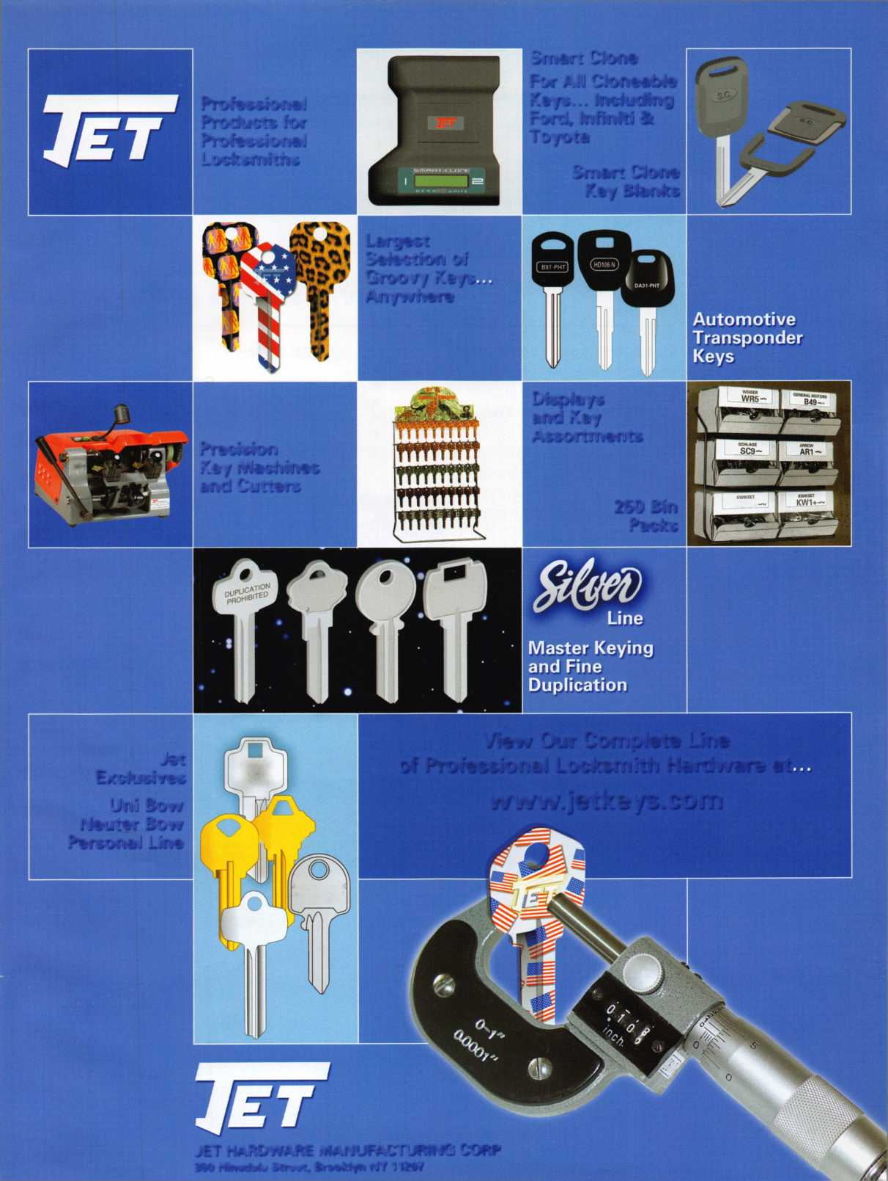

JUNE 15-22, 2008 • DALLAS, TEXAS

Strap on your cowboy boots! In 2008, we are cele­brating the 52nd annual ALOA Convention and Expo in Dal­las, Texas. ALOA 2008 of­fers plenty of exciting classes and seminars that will educate and expose you to some of the best security-related tech­nology the industry has to offer.

PLUS...MORE FUN!!

* Kick-Off Party
* ALOA Golf Tournament
* Tour
* Banquet
* Networking

Having built an international reputation among locksmiths as a powerful resource to ex­plore industry alliances, ALOA 2008 is the ideal place to learn, network or showcase your business on the show floor.

**For more information about Dallas, Texas please visit: www. dallascvb. com/visitors**

